Kubernetes

# Kubernetes

Will also called as k8s, is a very much decoupled. Is using for microservices

Please check differences between monolithic and microservices

K8s will works on **keys and certificates**, there in authorization mechanism in k8s.

Note: there is no option to create a separate container in kubernetes, so we will create a POD

Inside pod we will create containers and volumes.

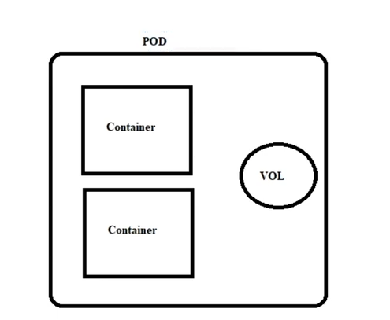

# What is Kubernetes?

http://linuxacademy.com Kubernetesisaplatform for managingcontainerized workloads.Kubernetesorchestratescomputing, networkingand storage to provide aseamlessportability acrossinfrastructure providers.

# Kubectl commands:

# ==>Viewing kubernetes Resource Information

## Nodes

$ kubectl get no

$ kubectl get no - o wide

$ kubectl describe no

$ kubectl get no - o yaml

$ kubectl get node - - select or =[ label _name]

$ kubectl get nodes - o jsonpath=' { . i t ems[ * ] . status. addresses [ ?( @. type==" External IP" ) ] . address} '

$ kubectl t op node [ node_name]

## Pods

$ kubectl get po

$ kubectl get po - o wide

$ kubectl describe po

$ kubectl get po --show- labels

$ kubectl get po -l app=nginx

$ kubectl get po -o yaml

$ kubectl get pod [ pod_name] -o yaml - - export

$ kubectl get pod [ pod_name] -o yaml - - export > nameoffile.yaml

$ kubectl get pods --field-select or status. phase=Running

$ kubectl get pods --v 6

$ kubectl get pods -n kube-system --v 6

## Namespaces

$ kubectl get ns

$ kubectl get ns - o yaml

$ kubectl describe ns

## Deployments

$ kubectl get deploy

$ kubectl describe deploy

$ kubectl get deploy - o wide

$ kubectl get deploy - o yaml

## Services

$ kubectl get svc

$ kubectl describe svc

$ kubectl get svc -o wide

$ kubectl get svc -o yaml

$ kubectl get svc --show-labels

$ kubectl get svc --v 6

## DaemonSets

$ kubectl get ds

$ kubectl get ds --all - namespaces

$ kubectl descr i be ds [daemonset _name] - n [namespace_name]

$ kubectl get ds [ds_name] - n [ns_name] - o yaml

## Events

$ kubectl get events

$ kubectl get events - n kube-system

$ kubectl get events - w

## Logs

$ kubectl logs [pod_name]

$ kubectl logs --since=1h [pod_name]

$ kubectl logs --tail =20 [pod_name]

$ kubectl logs -f -c [container _name] [pod_name]

$ kubectl logs [pod_name] > pod.log

## ServiceAccounts

$ kubectl get sa

$ kubectl get sa -o yaml

$ kubectl get serviceaccounts default -o yaml > . /sa.yaml

$ kubectl replaceserviceaccount defaul t -f ./sa.yaml

## ReplicaSets

$ kubectl get rs

$ kubectl describe r s

$ kubectl get rs -o wi de

$ kubectl get rs -o yaml

## Roles

$ kubectl get roles --all -namespaces

$ kubectl get roles --all -namespaces -o yaml

## Secrets

$ kubectl get secrets

$ kubectl get secrets --all -namespaces

$ kubectl get secrets -o yaml

## ConfigMaps

$ kubectl get cm

$ kubectl get cm --all -namespaces

$ kubectl get cm --all -namespaces -o yaml

## Ingress

$ kubectl get ing

$ kubectl get ing --all -namespaces

## PersistentVolume

$ kubectl get pv

$ kubectl describe pv

## PersistentVolumeClaim

$ kubectl get pvc

$ kubectl describe pvc

## StorageClass

$ kubectl get sc

$ kubectl get sc -o yaml

## MultipleResources

$ kubectl get svc, po

$ kubectl get deploy, no

$ kubectl get all

$ kubectl get all --all –namespaces

# ==>Changing kubernetes Resource Attributes

## Taint

$ kubectl taint [node_name] [taint _name]

## Labels

$ kubectl label [node_name] di sktype=ssd

$ kubrectl label [pod_name] env=prod

## Cordon/Uncordon

$ kubectl cordon [node_name]

$ kunectl uncordon [node_name]

## Drain

$ kubectl drain [ node_name]

## Nodes/Pods

$ kubectl delete node [ node_name]

$ kubectl delete pod [ pod_name]

$ kubectl edit node [ node_name]

$ kubectl edit pod [ pod_name]

## Deployments/Namespaces

$ kubectl edit deploy [deploy_name]

$ kubectl delete deploy [deploy_name]

$ kubectl expose deploy [deploy_name] --port =80 --type=NodePort

$ kubectl scale deploy [deploy_name] --replicas=5

$ kubectl delete ns

$ kubectl edit ns [ns_name]

## Services

$ kubectl edit svc [ svc_name]

$ kubectl delete svc [ svc_name]

## DaemonSets

$ kubectl edit ds [ds_name] -n kube-system

$ kubectl delete ds [ds_name]

## ServiceAccounts

$ kubectl edit sa [ sa_name]

$ kubectl delete sa [ sa_name]

## Annotate

$ kubectl annotate po [ pod_name] [ annotation]

$ kubectl annotate no [ node_name]

# ==>Adding Resources

## Creating a Pod

$ kubectl create -f [ name_of_file]

$ kubectl apply -f [ name_of_file]

$ kubectl run [ pod_name] --image=nginx --restart=Never

$ kubectl run [ pod_name] -- generator=run-pod/v1 --i mage=nginx

$ kubectl run [ pod_name] --image=nginx --restart=Never

## Creating a Service

$ kubectl create svc nodeport [svc_name] --tcp=8080:80

## Creating a Deployment

$ kubectl create -f [ name_of_file]

$ kubectl apply -f [ name_of_file]

$ kubectl create deploy [ depl oy_name] --image=nginx

## Interactive Pod

$ kubectl run [ pod_name] --i mage=busybox --rm -it --restart =Never --sh

## Output YAML to a File

$ kubectl create deploy [ deploy_name] --image=nginx --dry-run -o yaml > deploy.yaml

$ kubectl get po [ pod_name] -o yaml --export > pod.yaml

## Getting Help

$ kubectl -h

$ kubectl create -h

$ kubectl run -h

$ kubectl explain deploy.spec

# ==>Requests

## APICall

$ kubectl get –raw /apis/metrics.k8s.io/

## Cluster Info

$ kubectl config

$ kubectl cluster - info

$ kubectl get component statuses

# Disadvantages of microservices

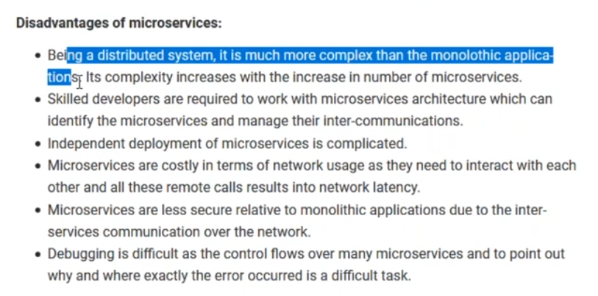

# Architecture

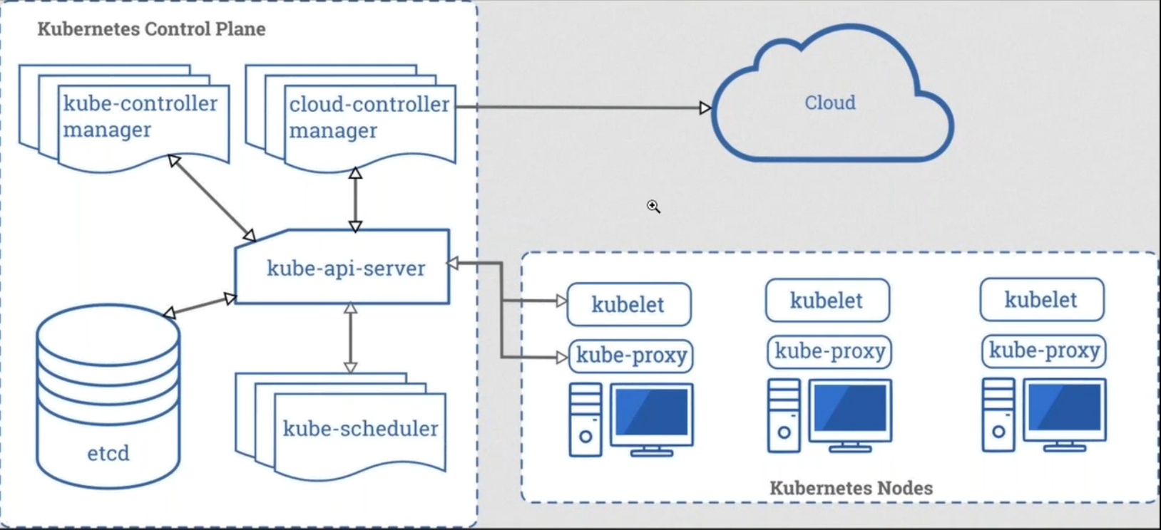

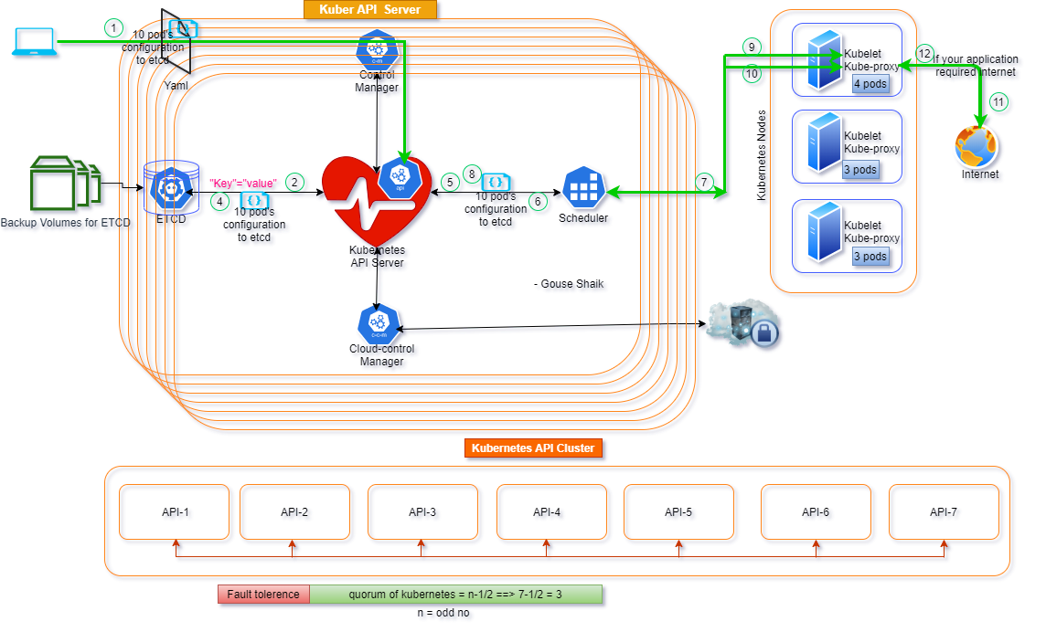

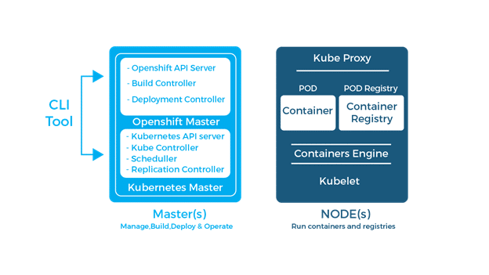

## We can manage kubernetes in two types

1. Kubectl ( as a scripted commands, its not a good practice so we should not use in our projects)

Ex: kubectl create deploy

1. YAML ( declarative syntax)

## Manifest

Manifest is a collection of your requirement to create pods.

# YAML( as a declarative syntax)

We can call as manifest for all declarative syntax in your YAML file

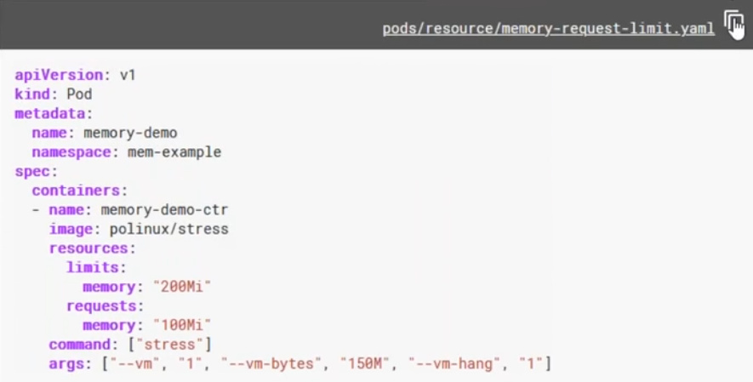

## Use --- for different multiple configurations

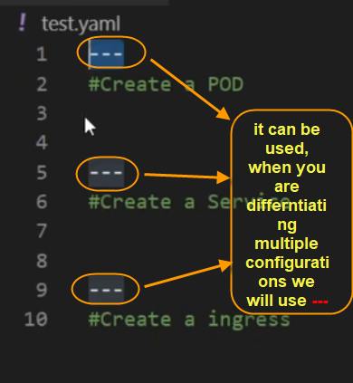

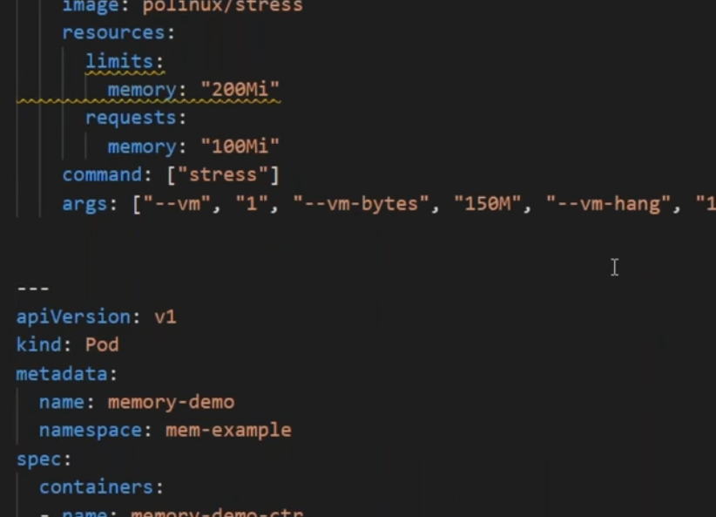

## Yaml file Intendation should be space, not with tabs

If you use spaces, no error shown

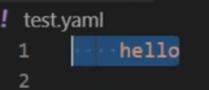

If you use tabs, it will error’d out

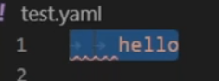

# JSON

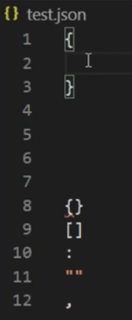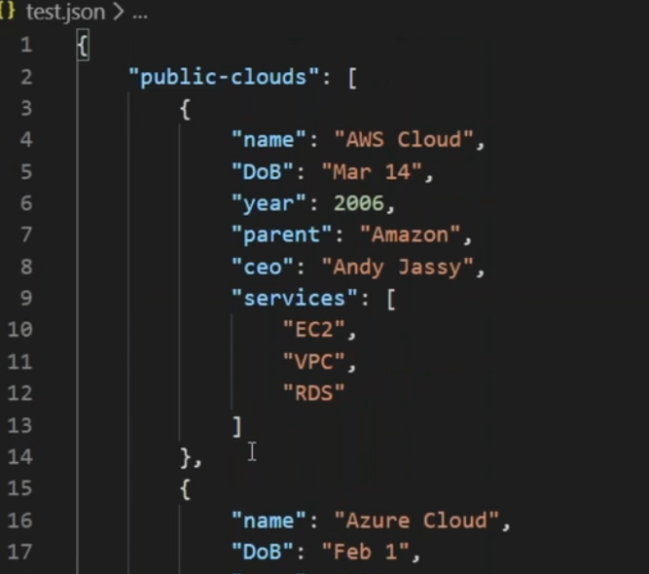

{} => for key pair value “key”: “value”

[] => for

CTRL + SHIFT + P in visual studio

## Compare YAML with JSON syntax

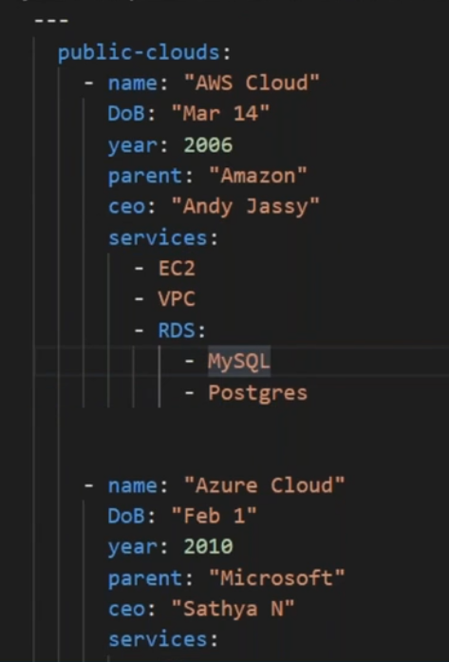

# Pod yaml

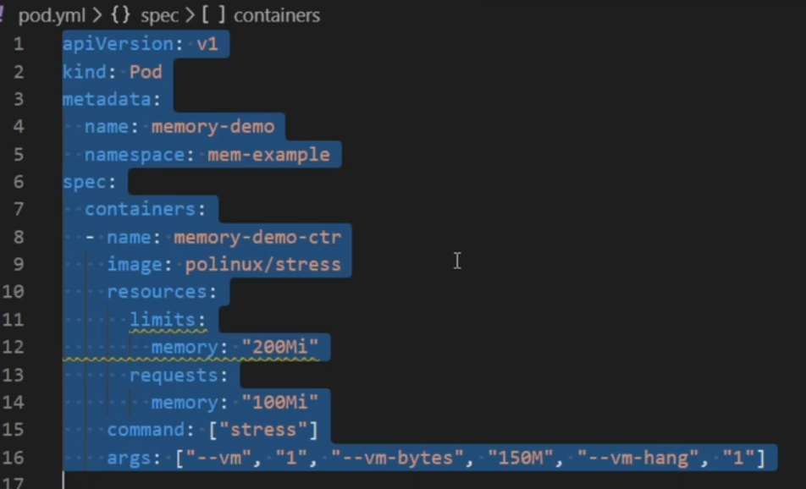

# [What is Amazon S3 bucket?](https://searchaws.techtarget.com/definition/AWS-bucket)

An Amazon S3 bucket is a public cloud storage resource available in Amazon Web Services' (AWS) Simple Storage Service (S3), an object storage offering.

**Note:** S3 will be charge, only unless any data inside se bucket

# Kubernetes types of setups

## Kubernetes Testing environments:

* Minikube (testing)
* Kubeadm (On-Prem/laptop) (kubeadm is a default tool given by kubernetes, for this the installation is bit difficult and hectic work(VPC, communications, kuebadm, etc..) so to avoid this we go with kops.

# Kubernetes Installation ways

There are numerous ways to install Kubernetes, following are some of the popular ways:

▪ **Kubeadm** – Bare Metal Installation

▪ **Minikube** – Virtualized Environment for Kubernetes

▪ **Kops** – Kubernetes on AWS

▪ **Kubernetes on GCP** – Kubernetes running on Google Cloud Platform

## Kubernetes Production grade environments:

* Kops (clouds(GKE,AKS, EKS), it will make your deployment makes easy.
* When you need cluster in your control, then you will use kops. Or else you can go with gke, aks, eks.
* It will install docker or cri from kops itself. This is the reason we are using kops instead of kubeadm

# KOPS Vs kubeadm

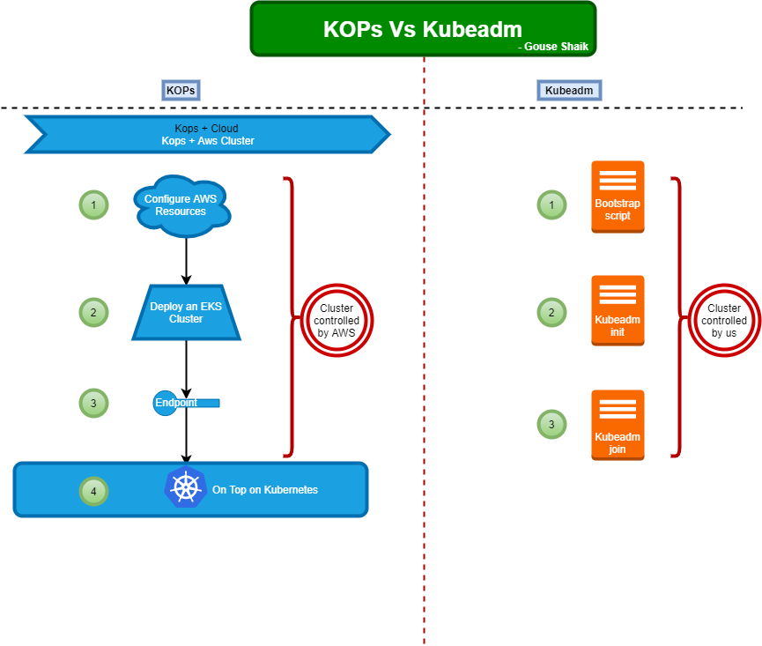

KOPS - Kops deployment steps

# KOPS - Kops deployment steps

### 1. Domain Name - Gousek8s.xyz (godaddy)

### 2. AWS Account

### 3. S3 Bucket & Route53 Domain Integration

### 4. Deploy a Mgmt Server which holds all scripts.

### 5. KOPS Binary(K8S Cluster Mgmt) & KUBECTL Binary(K8S Cluster Ops)

### (for Kops : https://github.com/kubernetes/kop)

### 6. SSH Public & Private Keys

### 7. AWS CLI and AWS Access/Secret Key (https://docs.aws.amazon.com/cli/latest/userguide/getting-started-install.html)

Move downloaded kops-linux-amd64 to /usr/localbin/kops

Kops cheat sheet: <https://lzone.de/cheat-sheet/kops>

## 2.1 Aws config for access key and secret key

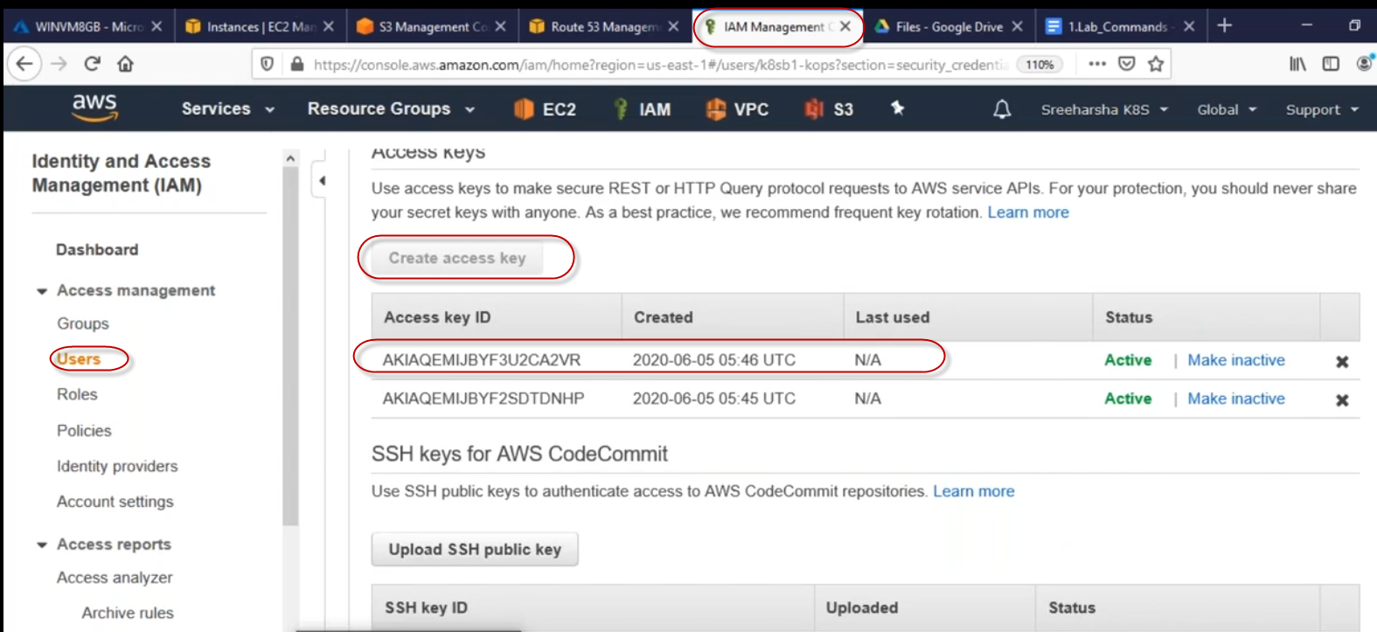

Goto your management server, and run “aws config”

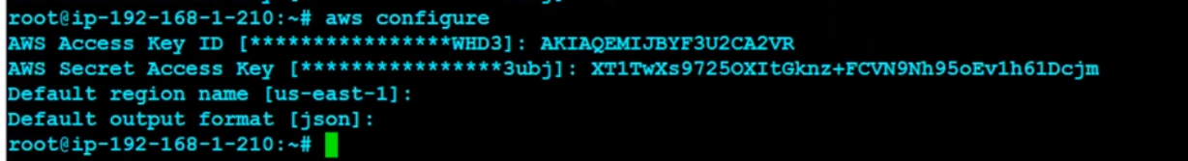

## authFailure error due to keys.

## kops exports:

<https://stackoverflow.com/questions/48084506/how-to-import-state-created-on-another-server>

.bashrc

Export NAME= Gousek8s.xyz

Export KOPS_STATE_STORE= s3://Gousek8s.xyz

alias ku=’kubectl’

export EDITOR=nano

## Kops master default volume size

The default volume size for Masters is 64 GB, while the default volume size for a node is 128 GB.

### To create a kops cluster

kops create cluster --name=Gousek8s.xyz --state=s3://Gousek8s.xyz --zones=us-east-1a --node-count=2 --node-size=t2.micro --master-size=t2.small --master-volume-size 20 --node-volume-size 10 --dns-zone=Gousek8s.xyz

kops create cluster --name=Gousek8s.xyz --state=s3://Gousek8s.xyz --zones=us-east-1a --node-count=2 --node-size=t2.micro --master-size=t2.small --master-volume-size 20 --node-volume-size 10 --dns-zone=Gousek8s.xyz --yes

### To know whether the cluster is deployed or not

watch –n 1 kubectl get nodes

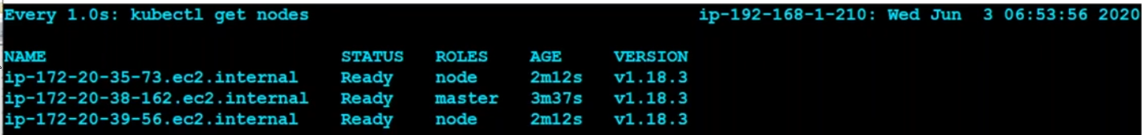

Ctrl+c to exit

Now we don’t have any work with kops

If you want to update nodes and more then only we can use kops.

## To retrieve management server details

$kubectl get pods –A

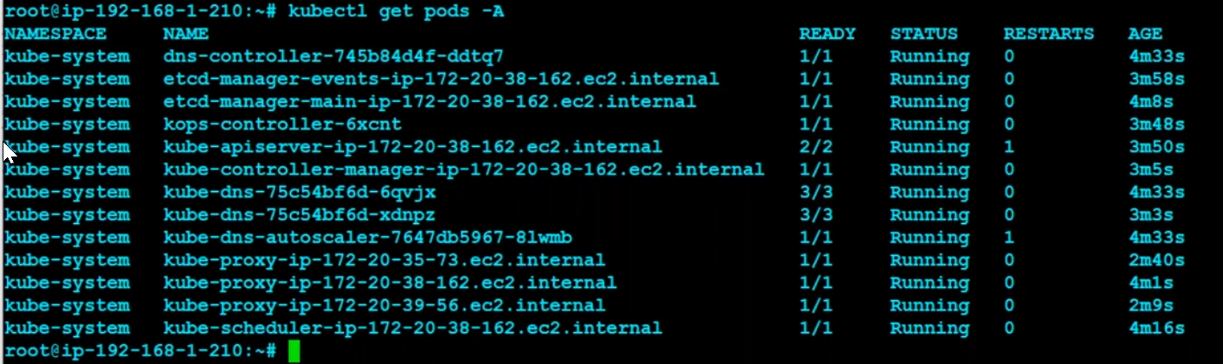

# About config file

Once you deployed kubernetes, one kube config file will be created under .kube

With this config file only all authentication will be happen for your kubernetes kops with the help of access_keys with awscli

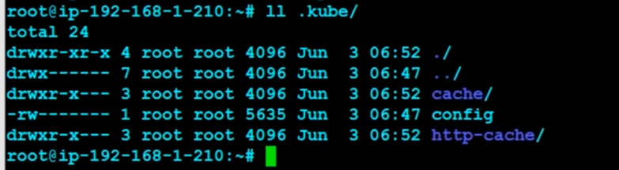

#### Before cluster deployment

##### # cat .kube/config

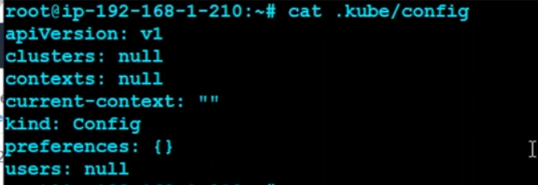

#### Running kops create cluster cmd

kops create cluster --name=Gousek8s.xyz --state=s3://Gousek8s.xyz --zones=us-east-1a --node-count=2 --node-size=t2.micro --master-size=t2.small --master-volume-size 20 --node-volume-size 10 --dns-zone=Gousek8s.xyz --yes

##### to watch –n1 kubectl get nodes



#### After cluster deployment

# cat .kube/config

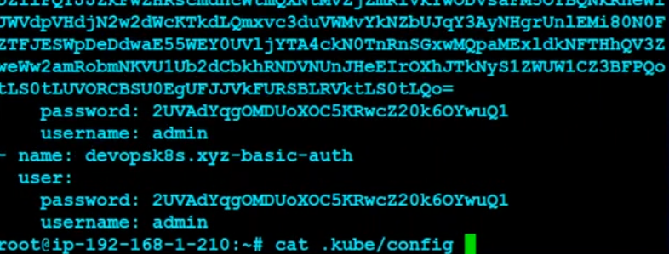

## Delete cluster

kops get cluster

kops get cluster –o yaml

kops delete cluster --name=Gousek8s.xyz --state s3://Gousek8s.xyz --yes

## to get the cluster details

kops get cluster --state s3://Gousek8s.xyz

kops get ig --name Gousek8s.xyz --state s3://Gousek8s.xyz

## to update master and nodes details

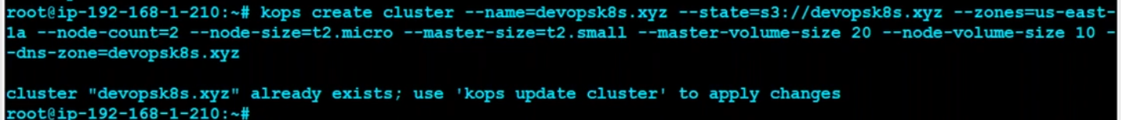

kops edit ig --name=Gousek8s.xyz master-us-east-1a --state s3://Gousek8s.xyz

kops edit ig --name=Gousek8s.xyz nodes --state s3://Gousek8s.xyz

## to rollout the our above changes

kops update cluster --name Gousek8s.xyz --yes --state s3://Gousek8s.xyz

## to watch our rollout chages



## To check our changes

Kubectl get nodes

It will take 10 to 20 mins time to deploy,

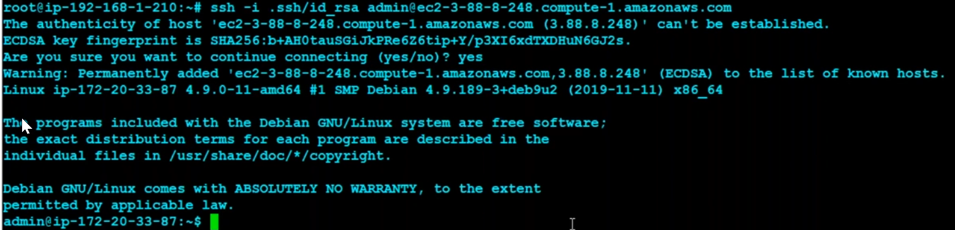

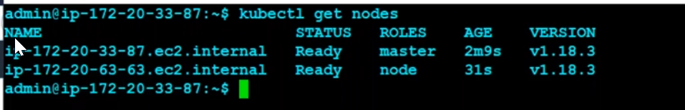

kops rolling-update cluster --name=Gousek8s.xyz --yes --state s3://Gousek8s.xyz

kops delete cluster --name=Gousek8s.xyz --state s3://Gousek8s.xyz --yes

ig = instance groups (it nothing but a groups of ec2 machines)

Once above lab test done, just delete it. Or else it will be charge.

# kuebnet

Kubenet : is for networking

## Kubernetes infrastructures

Kubernetes setup will be done with in two types

1. KOPs
2. kubeadm

## What is the difference between kops and kubeadm

### Kubeadm

**kubeadm** installs clusters on existing infrastructure. if you would rather have more control over your infrastructure, and are able to provide compatible infra for Kubernetes, then kubeadm may be a better option for you. Both are excellent production grade installers, but have different use cases.whereas,

### KOPs

**kops** builds the **EC2** instances for you, and can also build **VPC**, **IAM**, **Security groups** and a number of other features as well.

If you need **HA masters** or **manifest-based cluster** management, then kops may also be your first choice.

## Kubeadm & Kops for production grade clusters

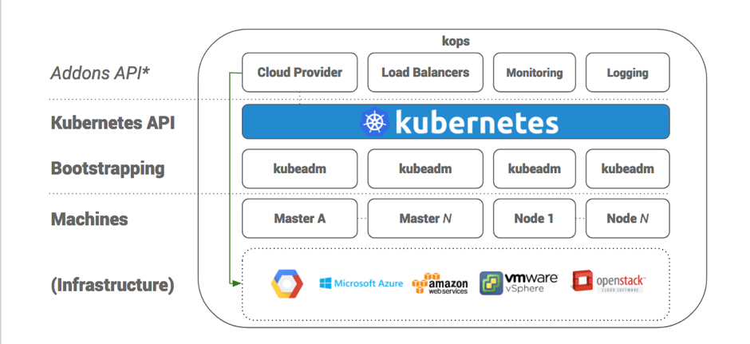

# KOPs: Install Kubernetes with native Kubeadm

<https://kubernetes.io/docs/setup/production-environment/tools/kubeadm/install-kubeadm/>

|  |  |
| --- | --- |
| kubeadm installation prerequisites | |
| Supported Machine type | Linux distributions based on Debian and Red Hat, and those distributions without a package manager |
| Supported CRI | Docker, Containerd, CRI-O |
| RAM | 2 GB or more |
| CPUs | 2 CPUs or more |
| Network | Full network connectivity between all machines in the cluster (public or private network is fine). |
| Uniqueness | hostname, MAC address, and product_uuid for every node [link](https://kubernetes.io/docs/setup/production-environment/tools/kubeadm/install-kubeadm/#verify-mac-address) |
| Ports | 6443, 2379-2380, 10250, 10259, 10257 [link](https://kubernetes.io/docs/setup/production-environment/tools/kubeadm/install-kubeadm/#check-required-ports) |

## **Control plane ports**

|  |  |  |  |  |
| --- | --- | --- | --- | --- |
| Protocol | Direction | Port Range | Purpose | Used By |
| TCP | Inbound | 6443 | Kubernetes API server | All |
| TCP | Inbound | 2379-2380 | etcd server client API | kube-apiserver, etcd |
| TCP | Inbound | 10250 | Kubelet API | Self, Control plane |
| TCP | Inbound | 10259 | kube-scheduler | Self |
| TCP | Inbound | 10257 | kube-controller-manager | Self |

Although etcd ports are included in control plane section, you can also host your own etcd cluster externally or on custom ports.

## **Worker node(s) ports**

|  |  |  |  |  |
| --- | --- | --- | --- | --- |
| Protocol | Direction | Port Range | Purpose | Used By |
| TCP | Inbound | 10250 | Kubelet API | Self, Control plane |
| TCP | Inbound | 30000-32767 | NodePort Services† | All |

## Kubernetes uses the [Container Runtime Interface](https://kubernetes.io/docs/concepts/overview/components/#container-runtime) (CRI)

If you don't specify a runtime, kubeadm automatically tries to detect an installed container runtime by scanning through a list of well known Unix domain sockets. The following table lists container runtimes and their associated socket paths:

|  |  |
| --- | --- |
| Runtime | Path to Unix domain socket |
| Docker | /var/run/dockershim.sock |
| containerd | /run/containerd/containerd.sock |
| CRI-O | /var/run/crio/crio.sock |

If both Docker and containerd are detected, Docker takes precedence. This is needed because Docker 18.09 ships with containerd and both are detectable even if you only installed Docker. If any other two or more runtimes are detected, kubeadm exits with an error.

The kubelet integrates with Docker through the built-in dockershim CRI implementation.

## Kubernetes support on updates

kubernetes will support only for last minor versions on current versions of kubernetes.

## FOR CONTROL PLANE:

### About kubeadm kubelet kubectl

Make sure you create the master server with 2CPU(Use t2.medium)

You will install these packages on all of your machines: [link](https://kubernetes.io/docs/setup/production-environment/tools/kubeadm/install-kubeadm/#check-required-ports)

* **kubeadm**: the command to bootstrap the cluster.
* **kubelet**: the component that runs on all of the machines in your cluster and does things like starting pods and containers.
* **kubectl**: the command line util to talk to your cluster. To manage cluster

### Installing kubeadm, kubelet and kubectl

## Bootstrap script

curl https://get.docker.com/ | bash

sudo apt-get update && sudo apt-get install -y apt-transport-https curl

curl -s https://packages.cloud.google.com/apt/doc/apt-key.gpg | sudo apt-key add -

cat <<EOF | sudo tee /etc/apt/sources.list.d/kubernetes.list

deb https://apt.kubernetes.io/ kubernetes-xenial main

EOF

sudo apt-get update

sudo apt-get install -y kubelet kubeadm kubectl

sudo apt-mark hold kubelet kubeadm kubectl

### Assign ip addresses to the containers/pods

### Note:

We are not creating network, just creating cidr range to use in this range only.

kubeadm init --pod-network-cidr 192.168.0.0/16

### Join worker node

BELOW COMMAND NEEDED TO BE EXECUTED IN THE WORKER NODE

kubeadm join 10.1.1.200:6443 --token ynogss.v28um8uq3pbza9mo \

--discovery-token-ca-cert-hash sha256:e5c238a5f964a05cdf2e09adfe8d3458eaabb6925327fa76849ae8463d0ea84f

### Create home directory for kube from your home directory

mkdir -p $HOME/.kube

sudo cp -i /etc/kubernetes/admin.conf $HOME/.kube/config

sudo chown $(id -u):$(id -g) $HOME/.kube/config

### To get the nodes before apply calico network

root@ip-10-1-1-81:~# kubectl get nodes

NAME STATUS ROLES AGE VERSION

ip-10-1-1-81 NotReady master 2m16s v1.18.3

### kubectl apply (for network (CNI – container network interface))

<https://kubernetes.io/docs/concepts/extend-kubernetes/compute-storage-net/network-plugins/>

its an network establishing in between pods.

kubectl apply -f https://docs.projectcalico.org/v3.14/manifests/calico.yaml

### Create alias for kubectl

alias ku=”kubectl”

### To get the nodes after apply calico network

root@ip-10-1-1-81:~# ku get nodes

NAME STATUS ROLES AGE VERSION

ip-10-1-1-81 Ready master 5m47s v1.18.3

### To get the pods info

#ku get pods -A

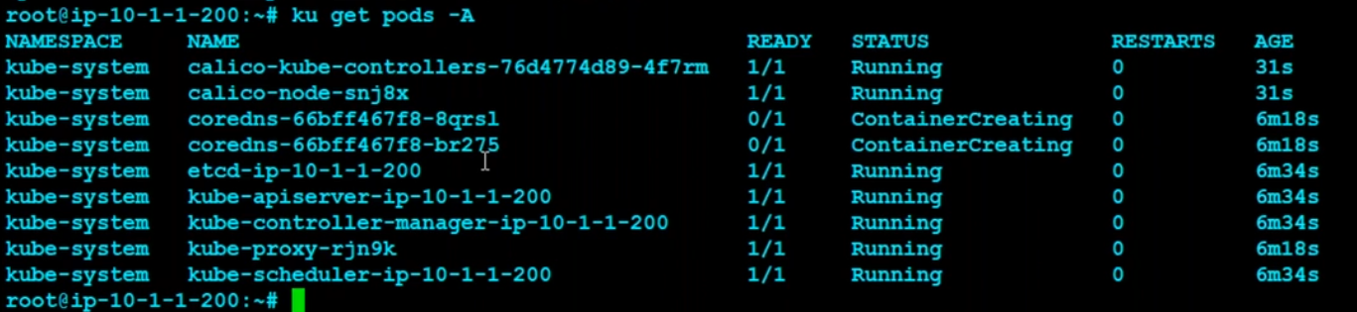

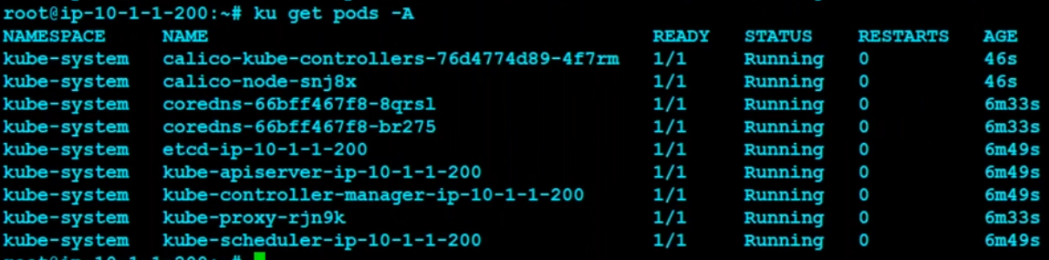

### To get the nodes status

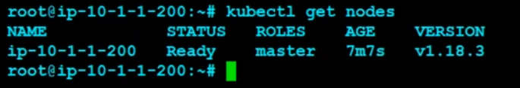

## ON WORKER NODE:

curl https://get.docker.com/ | bash

sudo apt-get update && sudo apt-get install -y apt-transport-https curl

curl -s https://packages.cloud.google.com/apt/doc/apt-key.gpg | sudo apt-key add -

cat <<EOF | sudo tee /etc/apt/sources.list.d/kubernetes.list

deb https://apt.kubernetes.io/ kubernetes-xenial main

EOF

sudo apt-get update

sudo apt-get install -y kubelet kubeadm kubectl

sudo apt-mark hold kubelet kubeadm kubectl

### To join this node with the cluster:

kubeadm join 10.1.1.81:6443 --token j1dmnn.5p2vhbau96eupjdl \

--discovery-token-ca-cert-hash sha256:cf2b3dc616f30fde87730fa1955a14b391eaf15d737be54d2d3a7c32634bc6ec

### To get the pods info

#ku get pods -A



Note, we will create separate namespaces for developers and they will do what they want on kubernetes inside the given name space.

There is an API groups concept(Important)

### To check the memory utilization with linux tools

* 1. top
  2. gtop

#### This node has joined the cluster:

* Certificate signing request was sent to apiserver and a response was received.

* The Kubelet was informed of the new secure connection details.

## AGAIN ON THE MASTER NODE:

### To get the before applying role as label.

root@ip-10-1-1-81:~# kubectl get nodes

NAME STATUS ROLES AGE VERSION

ip-10-1-1-81 Ready master 7m50s v1.18.3

ip-10-1-1-99 Ready <none> 2m14s v1.18.3

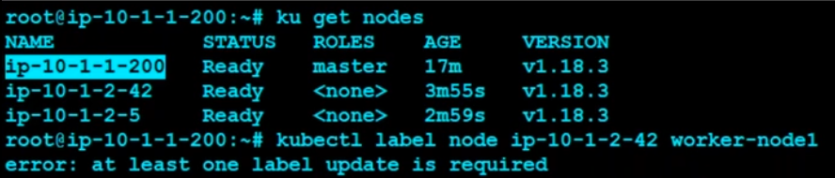



You will get master node information

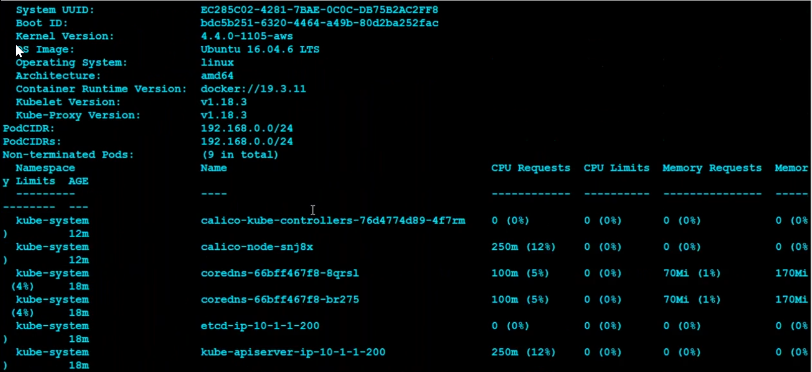

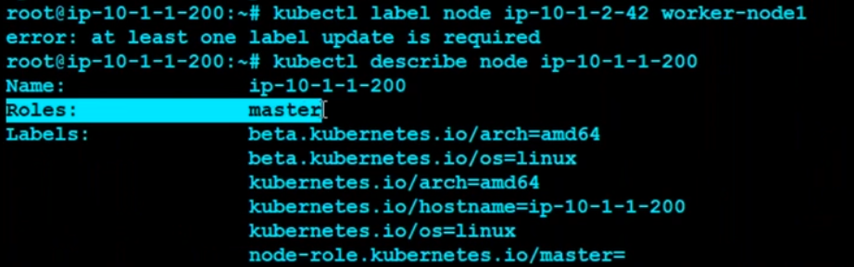

You can find Roles: master

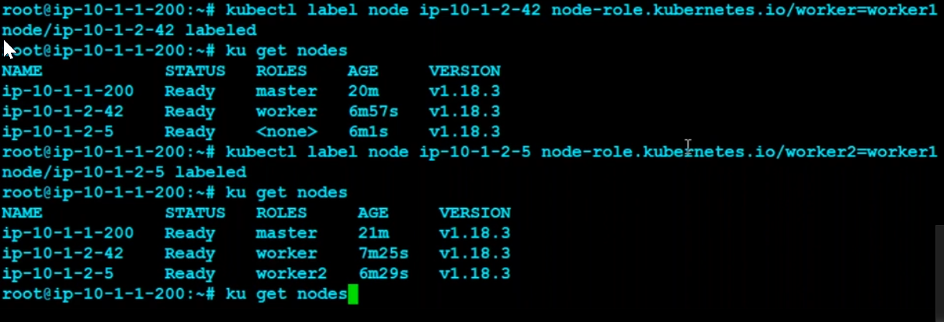

### To give label

root@ip-10-1-1-81:~# kubectl label node ip-10-1-1-99 node-role.kubernetes.io/worker=worker

node/ip-10-1-1-99 labeled

### To get the after applying role as label.

root@ip-10-1-1-81:~# ku get nodes

NAME STATUS ROLES AGE VERSION

ip-10-1-1-81 Ready master 8m19s v1.18.3

ip-10-1-1-99 Ready worker 2m43s v1.18.3

To remove the role as label

root@ip-10-1-1-81:~# kubectl label node ip-10-1-1-99 node-role.kubernetes.io/worker=worker2-

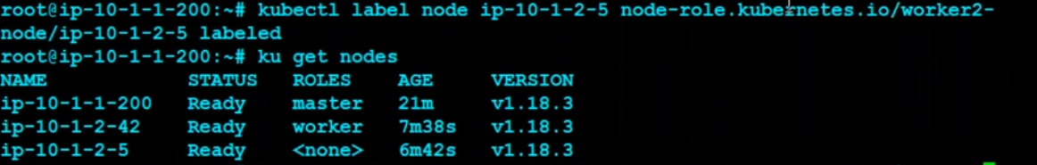

Again given with label “worker”

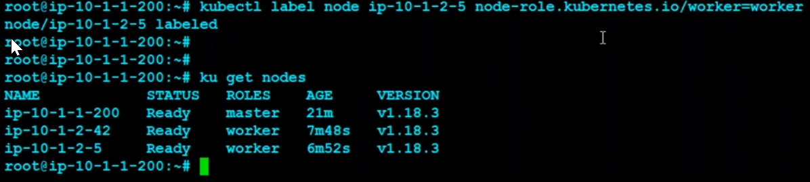

==============================As per above steps, our cluster is up====================

To check the kubernetes config in master

Cd $HOME

# cat .kube/config

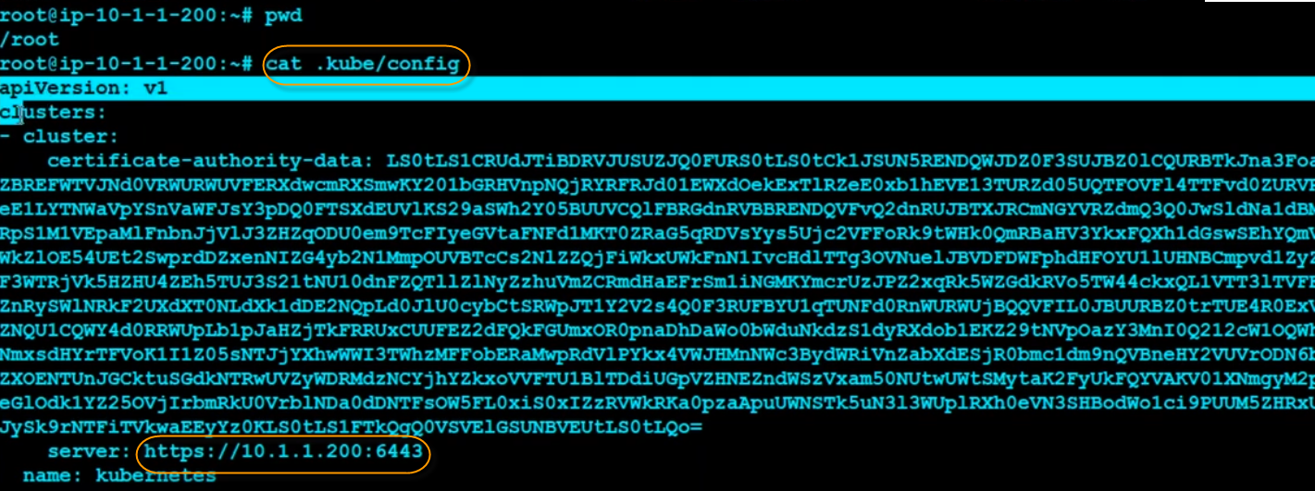

If you observe, public DNS names will come when you use **kops**

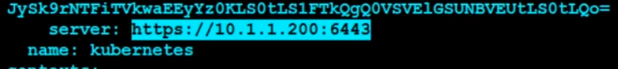

While for **kubeadm**, we are getting private DNS.

## All keys will store here



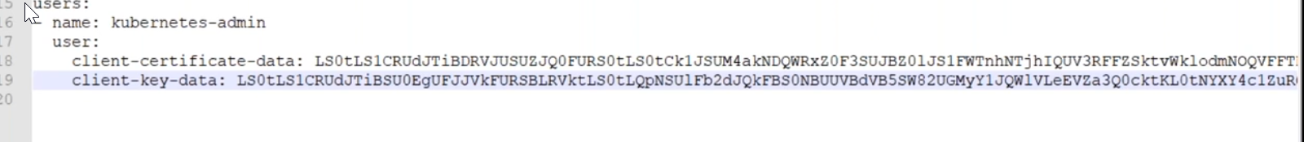

If the config key data changed, you cant connect with kubernetes cluster.

So make sure to keep it safe.

## ADDING ADDITIONAL NODE TO CLUSTER:

kubeadm token create --print-join-command

kubeadm join 10.1.1.200:6443 --token azk1md.l4uojch8lssib3a8 --discovery-token-ca-cert-hash sha256:e5c238a5f964a05cdf2e09adfe8d3458eaabb6925327fa76849ae8463d0ea84f

### to create a pod

#ku run testpod –image=index.docker.io/shreeharshav/rollingupdate:v3

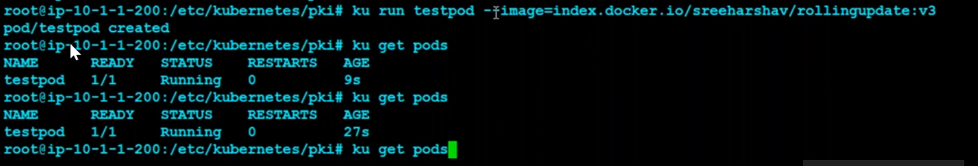

### To list pod in wide output

# ku get pods –o wide



### To list pod details in yaml format

# ku get pods –o yaml

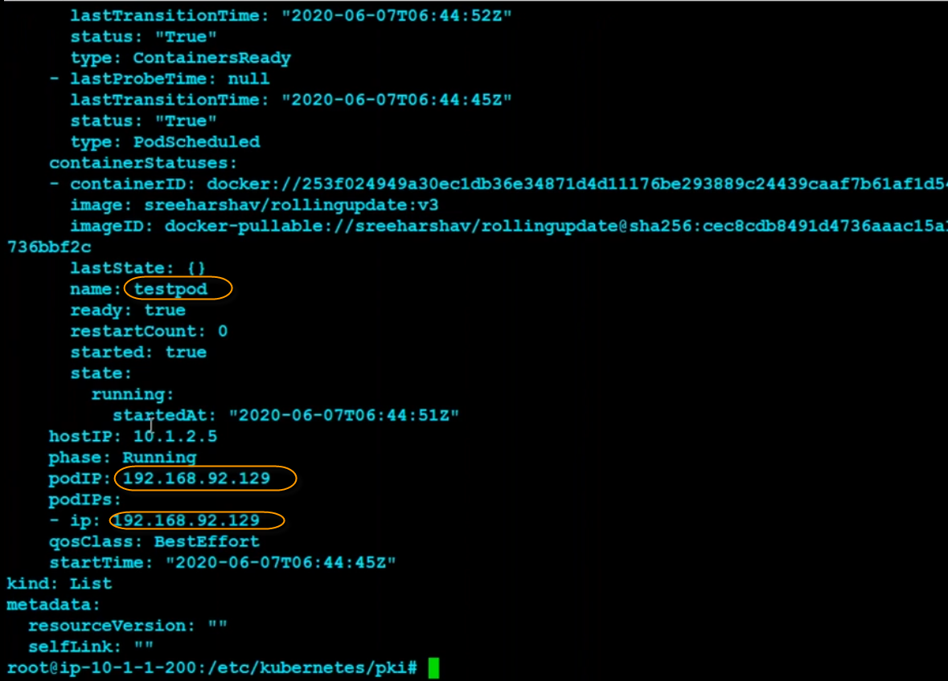

### To get executed the shell in pod

# ku get pods

#ku exec –it testpod ls /etc

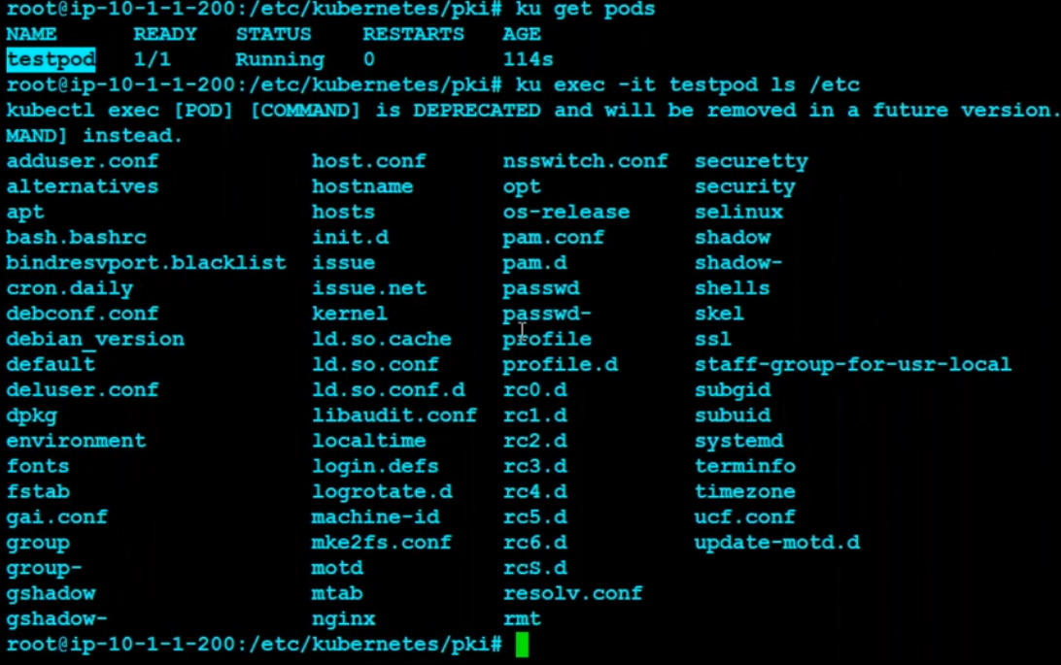

### To enter multiple commands use --

# ku exec --it testpod – df -h

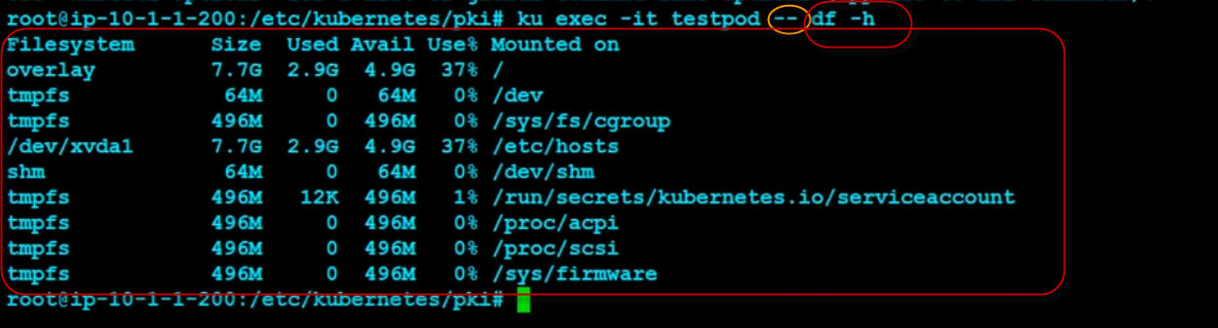

### To get the service

# ku get service

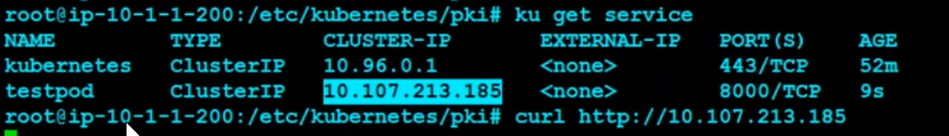

Curl http://10.107.213.185:8000

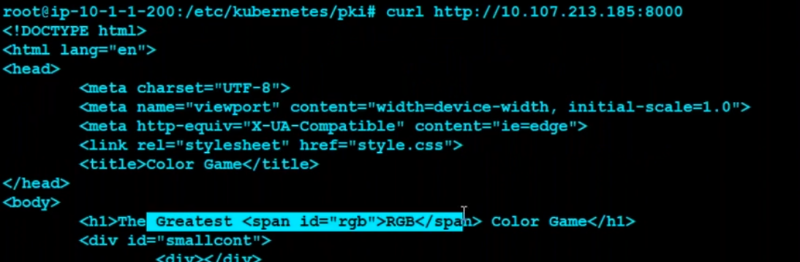

### To expose port

# ku expose pod testpod --port=8000 --target-port=80 --type=NodePort

### To check the service ports

# ku get svc

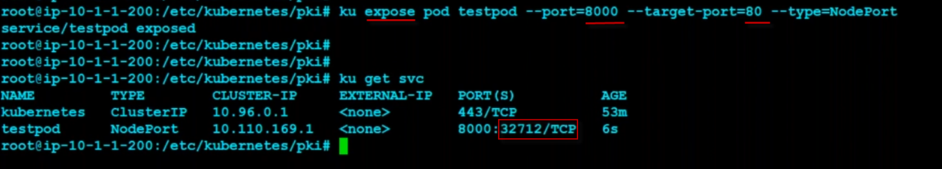

Note: in **kops** we will not allow security groups, so the same url will not open in kops

In **kubeadm**, we allowed security groups, so we are able to access below app url.

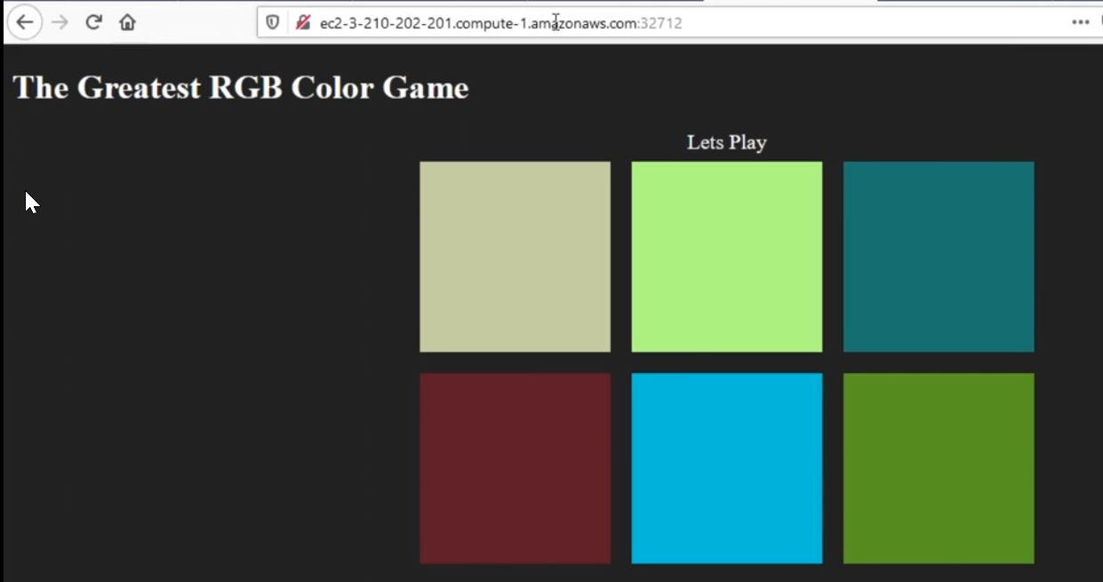

## DRAINING and DELETING NODE:(we will not do in realtime, unless you want to decommission the node)

### Drain the node by IP

# ku drain ip-10-1-2-5 --force --ignore-daemonsets

### To check the nodes status , which is drained

root@ip-10-1-1-200:/etc/kubernetes/pki# ku get nodes

NAME STATUS ROLES AGE VERSION

ip-10-1-1-200 Ready master 57m v1.18.3

ip-10-1-2-42 Ready worker 43m v1.18.3

ip-10-1-2-5 Ready,SchedulingDisabled worker 42m v1.18.3

ip-10-1-3-58 Ready worker 12m v1.18.3

### To delete kubernetes node

# ku delete node ip-10-1-2-5

### Single command to drain and delete the node

ku drain ip-10-1-2-42 --force --ignore-daemonsets && ku delete node ip-10-1-2-42

ku drain ip-10-1-3-58 --force --ignore-daemonsets && ku delete node ip-10-1-3-58

### To check the pods, whether its deleted or not

# ku get pods

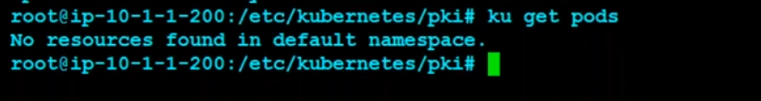

### To check the nodes

# ku get nodes

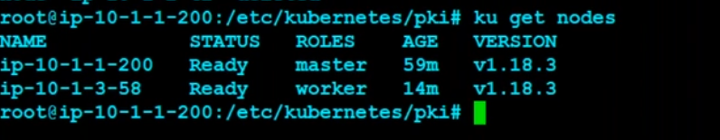

## Terminate machines

Once your lab done, select all images 🡪 right click 🡪 terminate. Just terminate all machines

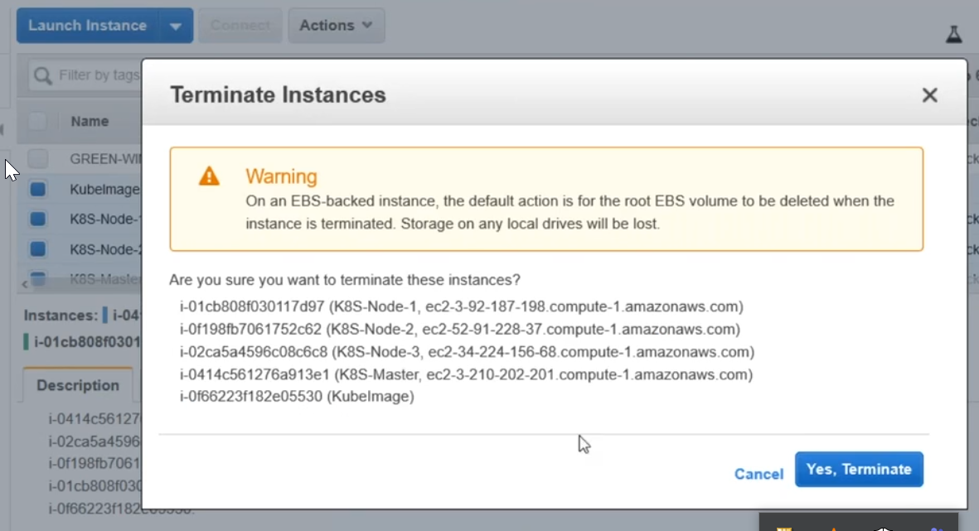

# KOPs: install pods

## Procedure to connect master from windows machine.

1. first login to master, to get the ssh key

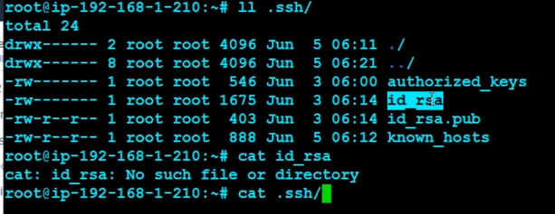

1. then copy all content of the id_rsa
2. save as keyfile.pem

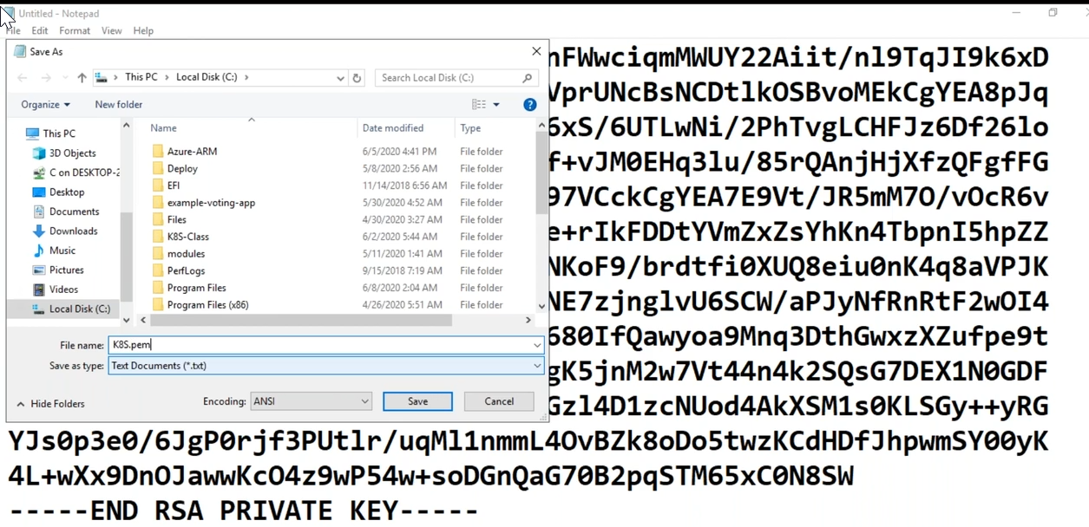

1. load the pem file into Putty Key Gen

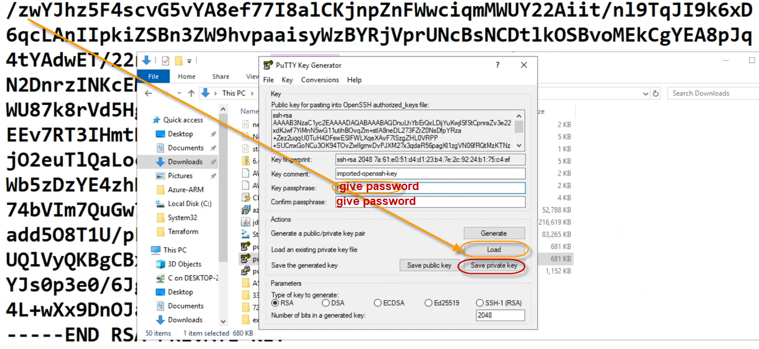

1. click on Save private Key and save it as privatekey.ppk file

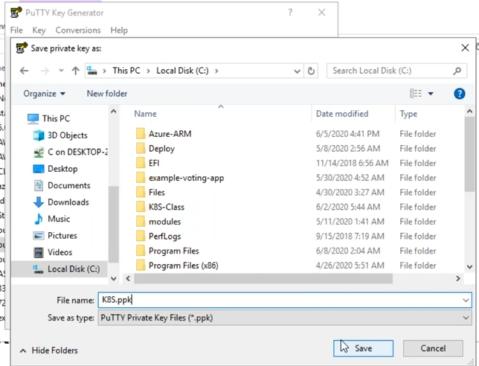

1. now connect to server with this ppk file

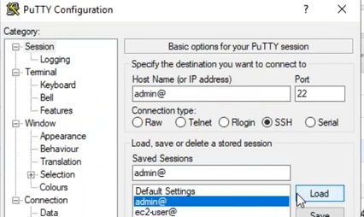

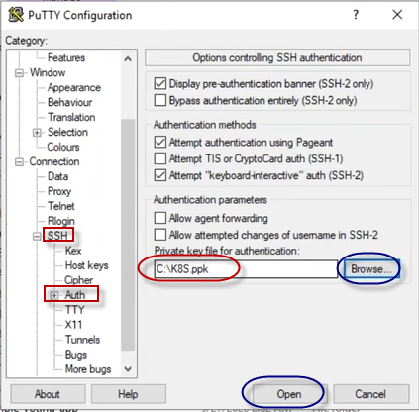

1. Now user@hostname from aws and login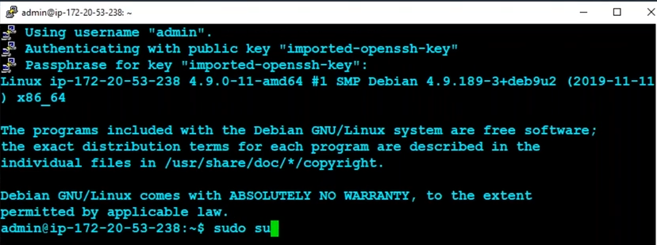
2. Note, here we already configured already kubadm on this machine. We are just tryting to connect with admin user.

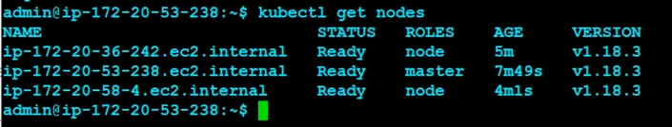

You can see the $, instead of # prompt.

Note, you can do it with ssh key on the server. But we have done the above steps to connect from putty on windows.



There is no option to create a separate container in kubernetes, so we will create a POD

Inside pod we will create containers and volumens.



1. Mostly one POD contains one container only. But it’s not mandatory.

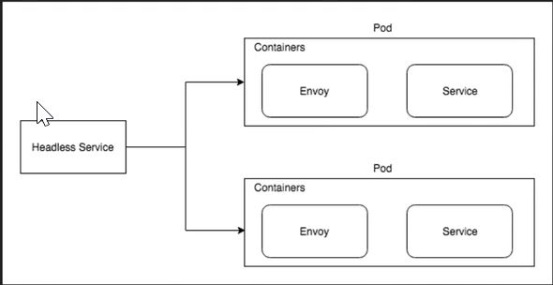

## Get pods from default namespace

$ ku get pods



## Get pods from kube system

$ku get pods –A

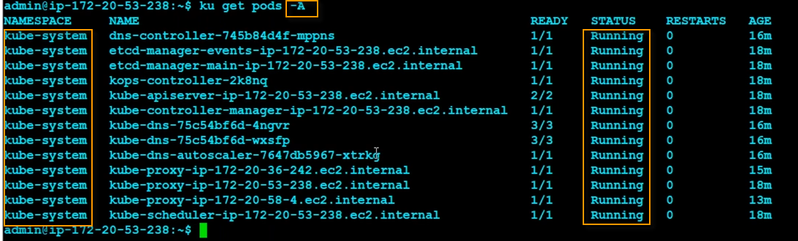

## Create pods with kubectl

We can create our own PODs.

We can go first with kubectl commands to create pods

## Creating a pod from dockerhub repo

$ kubectl run testpod1 –name=index.docker.io/gowseshaik/monit:1.0

pod/testpod1 created

## To get the pods list status

$ kubectl get pods

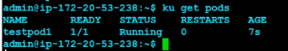

## ImagePullBackOff issue

Incase if you have created the wrong pod

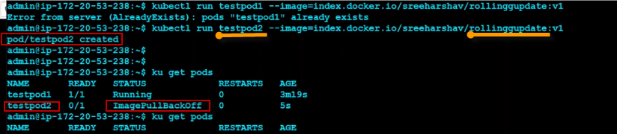

## To get the in-depth details of your pod with describe

$ ku describe pod testpod1

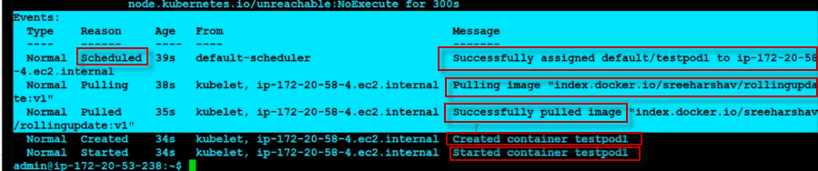

1. Scheduler will continuously check for if any new pod, and it will assign the ip to pod
2. Then it will get the container from container registry hub
3. And if everything is fine it will show pulled successfully, or else will show an error.
4. If container pulled successfully, container will be created for the pod
5. And finally it will start the container from the pod.

Alias dpod=’kubectl describe pod’

## Trying to create a wrong container with pod

$ ku describe pod testpod2

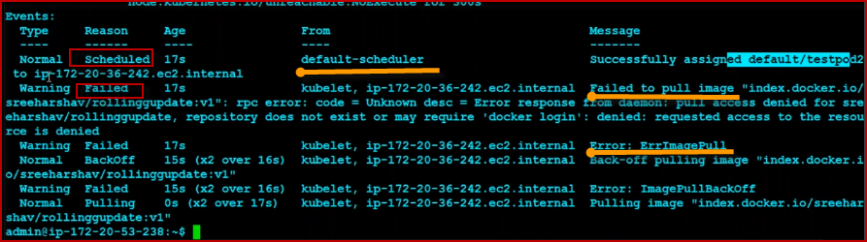

## Pod Ready 1/1 or 0/1

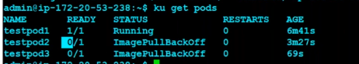

1/1 : pod contains 1 container and 1 is running

0/1 : pod contains 1 container and 0 running

## To delete pod

$ ku delete pod testpod3

## To edit the pod

And to check the configuration of the pod to correct it

$ ku edit pod testpod2

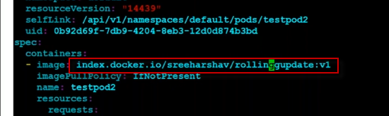

We know in this pod, is failed due to image from the describe command.

And now we corrected with right repo name.

And if you re run the pod creation, it will automatically successfully pulled and the status will be in running. With 1/1

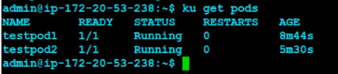

Note: Basically we should not update. But if you check in pods describe, don’t create.

So better way to delete the pod. Then re-run the pod creations. Then only all logs will be generate successfully.

## To expose the pod use the services

Services can be used for to expose our container from Outside the cluster or over the internet you can use services

$ ku expose pod testpod2 --port=8000 --target-port=80 --type=NodePort



### To check whether the service is exposed or not

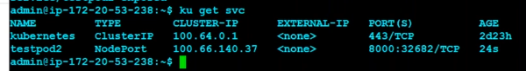

## To get all pods

$ ku get all

## For testing purpose use port-forwarding

$ ku port-forward pod/testpod1 8888:80

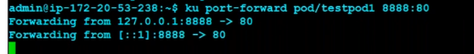

curl <http://localhost:8888>

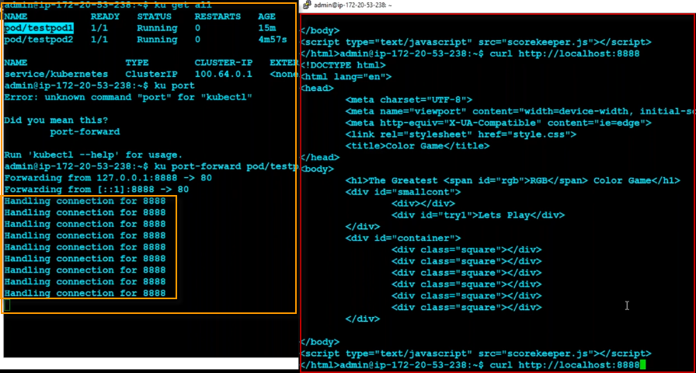

## To port-forwarding from local

$ cat .kube/config from management server

Copy the content and paste it

Config file in your local

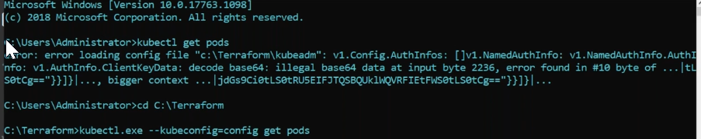

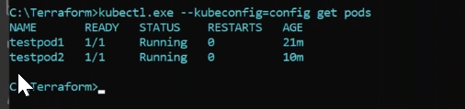

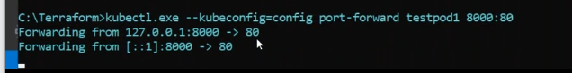

$ kubectl.ext –kubeconfig=configfile port-forward testpod1 8000:80

Open browser in your windows local machine. Its proxying from local to server.

<http://localhost:8000>

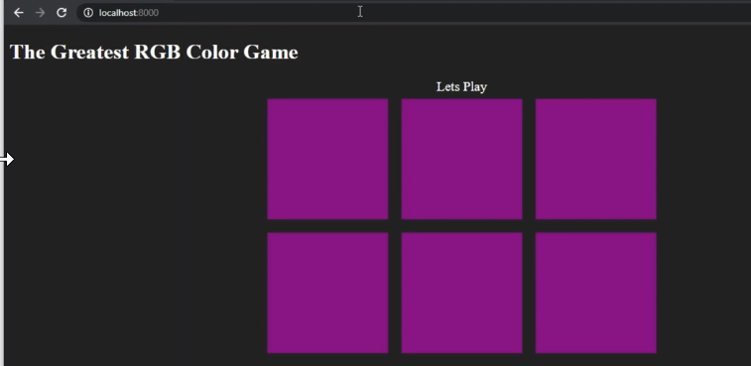

## To get the all information of deployed pod in the form of yaml

$ ku get –o yaml

## To exec inside the pod



$kubectl exec –it testpod1 -- ls -ltr

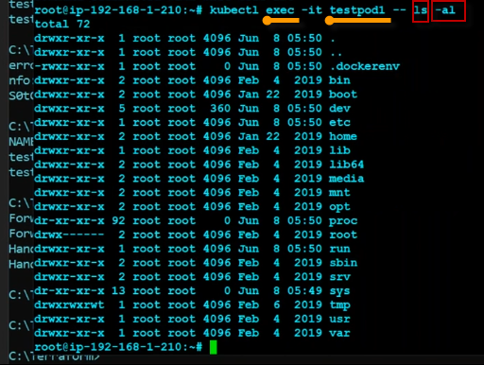

## To exec pod inside a bash

$ kubectl exec --it testpod1 -- bash



## To install ping

$ sudo apt install iputils-ping

Kubernetes is a flat network, there is no network communication

**Layer3 network**, to communicate we need routers

10.1.1.10

10.1.2.10

**In kubernetes**

100.*/10 🡪 it will communicate with in all pod, if you want to stop communicate then, we have to use 3rd party plugins to stop.

## Pod deployment with yaml

vi [pods/simple-pod.yaml](https://raw.githubusercontent.com/kubernetes/website/main/content/en/examples/pods/simple-pod.yaml)

**apiVersion**: v1

**kind**: Pod

**metadata**:

**name**: nginx

**spec**:

**containers**:

- **name**: nginx

**image**: nginx:1.14.2

**ports**:

- **containerPort**: 80

To create the Pod shown above, run the following command:

kubectl apply -f <https://k8s.io/examples/pods/simple-pod.yaml>

create a namespace first and then use the namespace in your yaml file, or else no need to mention namespace in your yaml file.

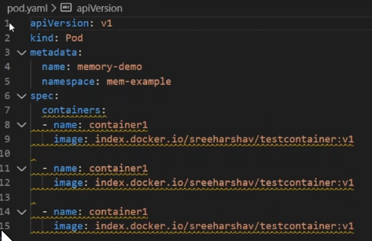

Ctrl+shift+p to format the file

### To validate yaml

<https://kubeyaml.com/>

<https://k8syaml.com/>

<https://learnk8s.io/validating-kubernetes-yaml>

<https://www.kubeval.com/>

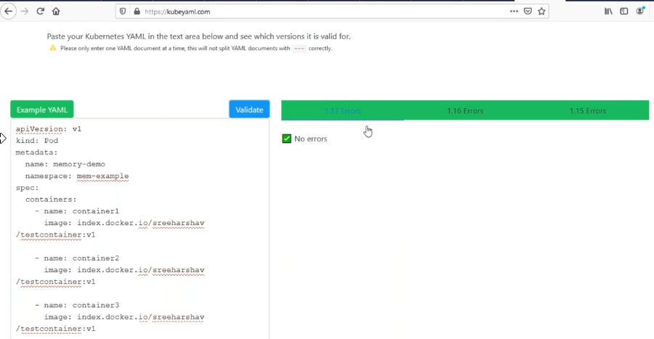

### To create a pod with yml file

$kubectl create –f pod.yml

$ku get pods

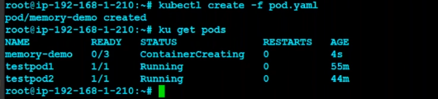

If you observe zero containers running out of 3 containers.

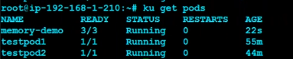

3 containers are running without any issues inside the pod memory-demo. 3/3

$ ku describe pod memory-demo

Under Events:

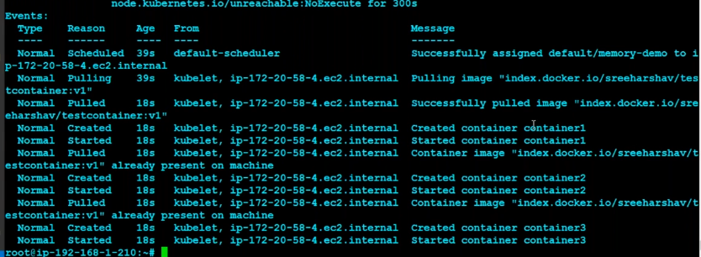

If you observe, the given 3 Containers in yaml, are created with same ip, which was allocate to the pod.

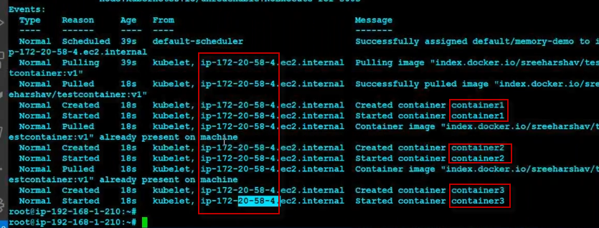

But there is no use, if the pod is down then all 3 containers will be down. So there will be no use of creating pod like above.

So now, edit the pod configuration

$ ku edit pod memory-demo



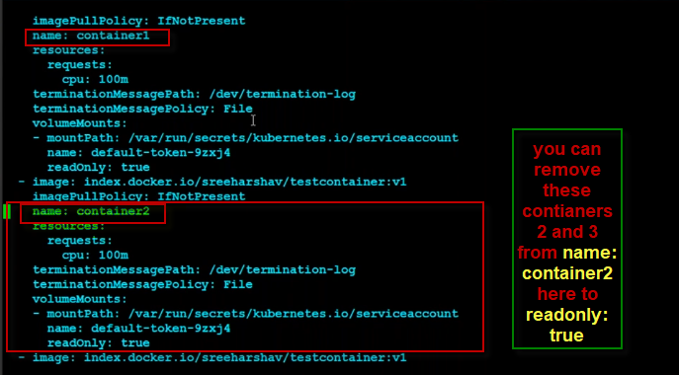

To delete all pods

$ ku get pods

$ ku delete pod memory-demo

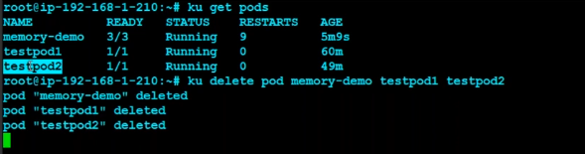

## To create a namespace

Mention namespace: ns1 in yaml file and create pod

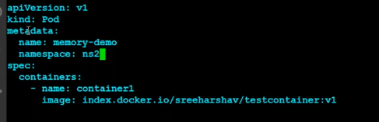

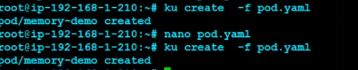

$Ku get pods

$ku get pods -A



$ ku get pods –n ns1

$ ku get pods –n ns2



$ ku describe pod –n ns2 memory-demo

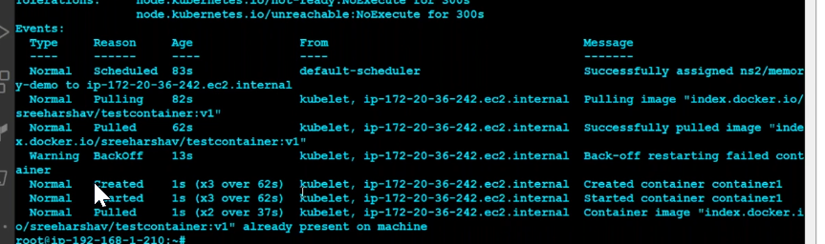

$Ku exec –it memory-demo –n ns1 –bash

Container getting crashed.

### CrashLoopBackOff

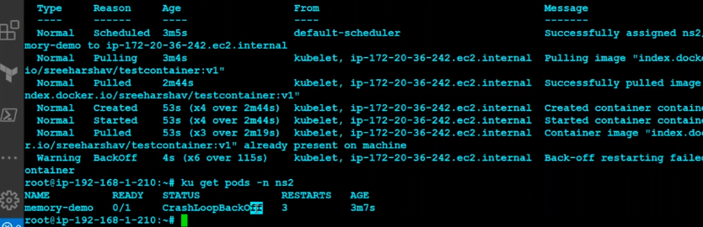

$ku get pod –n ns2 –o yaml

Get the – ip : ***.**..

$ku get pod –n ns1 –o yaml

Get the – ip : ***.**..

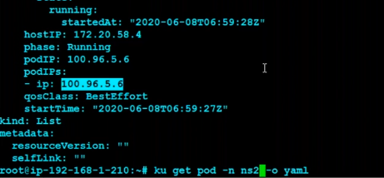

$Ku exec –it memory-demo –n ns1 -- bash

# apt install iputils-ping

#ping 100.96.4.8

## Namespace

Namespace: we use the namespace, to partitions our cluster to different parts.

## Controlling with network policies

Calico network policy between pods

## Create a httpd container in a pod

$Kubectl run hello --image=httpd:latest

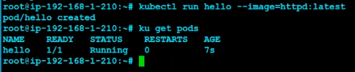

## To check the output in yaml format

$ku get pod hello -o yaml

In ongoing sessions we will check

* Annotations
* labels

and note: HostIp , PodIP and etc things will be updated by kubernertes.

Reference: search keyword in google with “kubernetes pod yaml reference” in your kubernetes exam you can refer the reference.

<https://kubernetes.io/docs/concepts/overview/working-with-objects/kubernetes-objects/>

<https://kubernetes.io/docs/reference/>

<https://kubernetes.io/docs/reference/generated/kubernetes-api/v1.22/>

<https://kubebyexample.com/en/concept/pods>

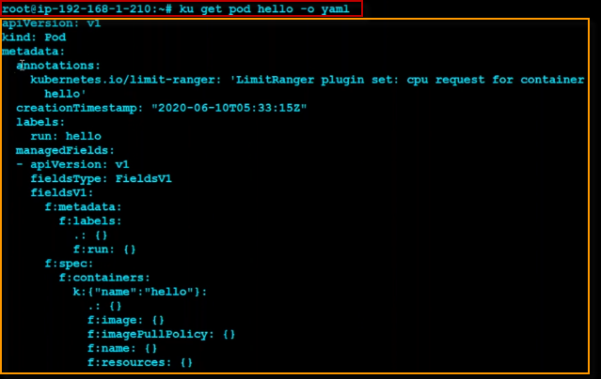

## Creating a pod with labels by yaml

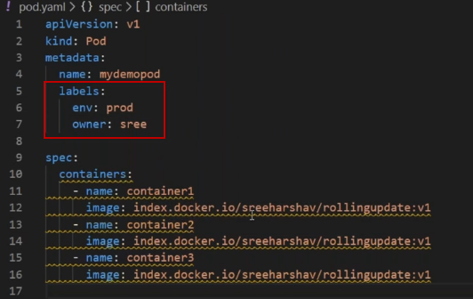

$ ku get pods

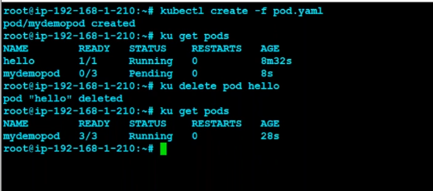

All 3 containers are running in this pod on same host.

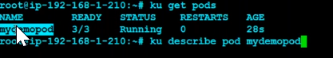

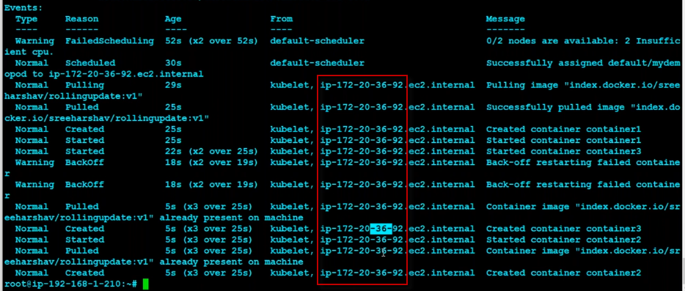

But you can observe that pod is crashing.

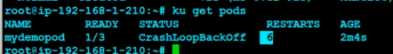

Lets edit the yaml file to fix this issue

$nano pod.yaml

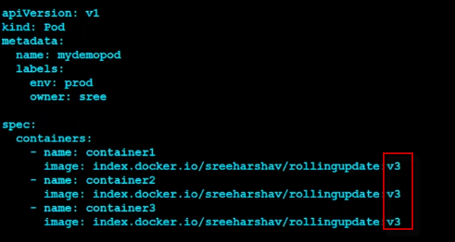

Let’s identify whether it’s in image problem or yaml problem

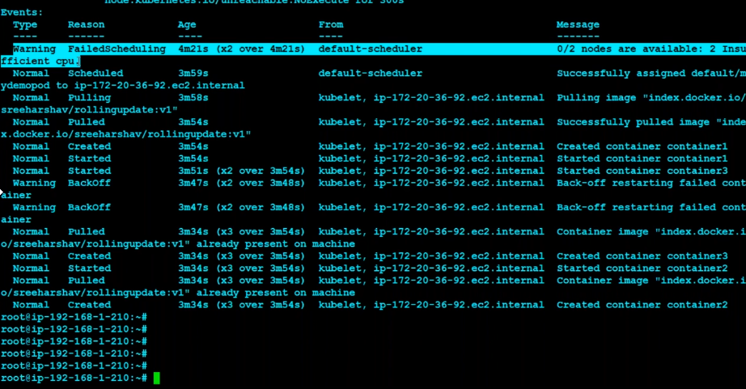

$ku get nodes

Here the volume is not enough, because its all 3 containers running on one pod of host

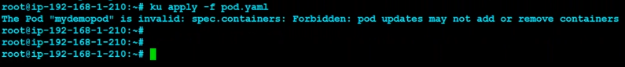

## To open the pod configuration

$ ku apply -f pod mydemopod

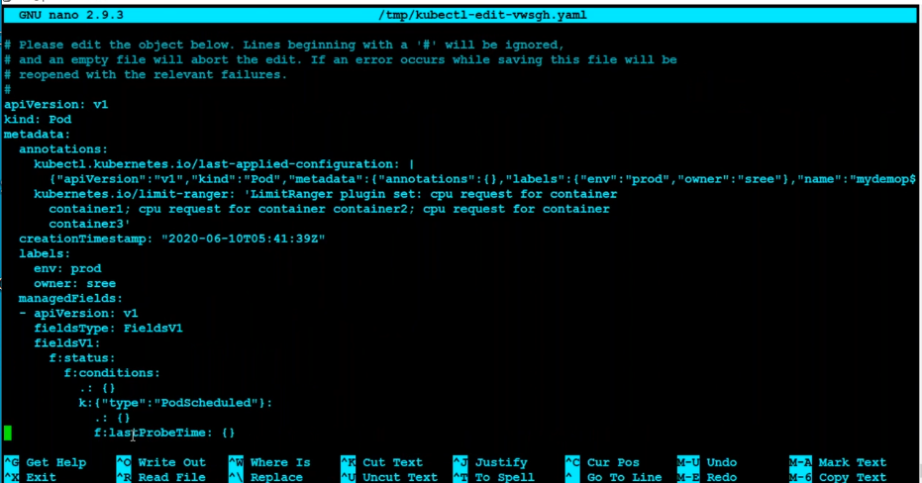

## Kubernetes containers limitation of pod

Each Container has a limit of 0.5 cpu and 128MiB of memory. You can say the Pod has a request of 0.5 cpu and 128 MiB of memory, and a limit of 1 cpu and 256MiB of memory.

**For an example**

apiVersion: v1

kind: Pod

metadata:

name: cpu-demo

namespace: cpu-example

spec:

containers:

- name: cpu-demo-ctr

image: vish/stress

resources:

limits:

cpu: "1"

requests:

cpu: "0.5"

args:

- -cpus

- "2"

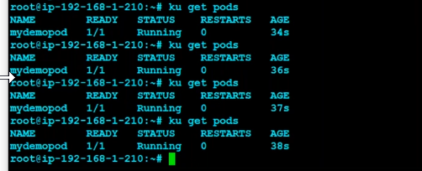

In above snapshot, we have updated the yaml with only one container

And it is running fine.

# Labels are?

* Labels are Random :
* Labels are Arbitary :

## To show the labels

$ ku get pods –l –show-all

$ ku get pods –l env=dev

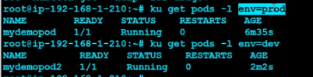

# Annotations

It is like a comments., it will not use for sorting.

## To give the annotations

$ku annotate pod mydemopod2 data=dfdsafhdsafajewrjsakfjsafjsa



### Difference between labels and annotations

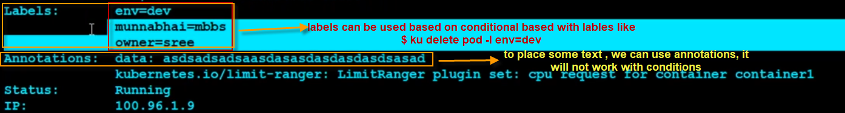

## Update pod yaml file

$nano pod.yml

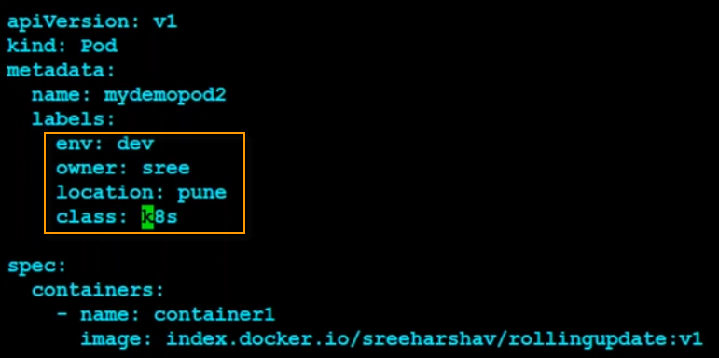

Once you updated pod yaml, You must apply with

## Apply pod changes

$ kubectl apply –f pod2.yml

## To show all pods labels

$ ku get pods –show-labels

## Difference between pod create vs apply

|  |  |  |
| --- | --- | --- |
| **S. No.** | **Kubectl apply** | **Kubectl create** |
| **1.** | It directly updates in the current live source, only the attributes which are given in the file. | It first deletes the resources and then creates it from the file provided. |
| **2.** | The file used in apply can be an incomplete spec | The file used in create should be complete |
| **3.** | Apply works only on some properties of the resources | Create works on every property of the resources |
| **4.** | You can apply a file that changes only an annotation, without specifying any other properties of the resource. | If you will use the same file with a replace command, the command would fail, due to the missing information. |

<https://stackoverflow.com/questions/47369351/kubectl-apply-vs-kubectl-create>

## filter with label of specific pod

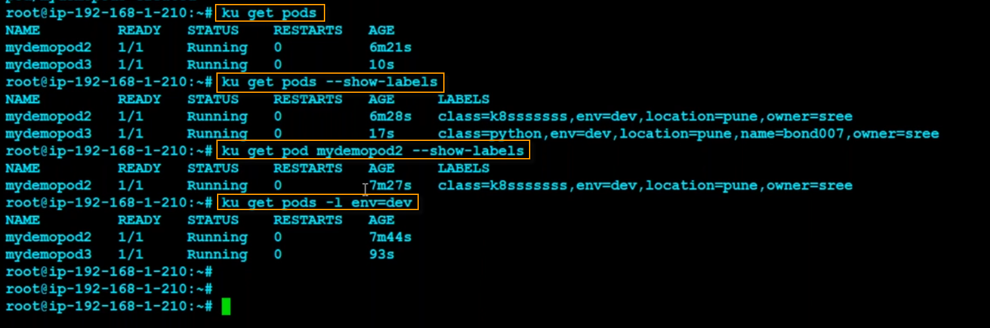

**Don’t do with commands its not a right way or best practice to do, please use declarative syntax as yaml file**

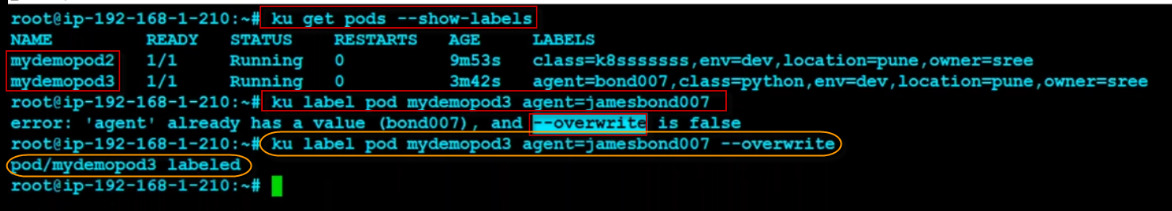

## Port forwarding with cli

$ ku expose pod mydemopod3 –port=8000 --target-port=80 --type=NodePort

$ kup get svc

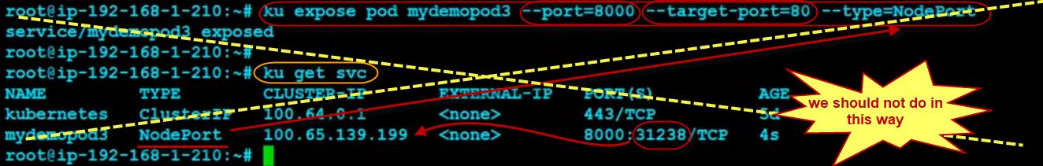

## To delete this svc

$ ku delete svc mydemopod3

## Lets delete all pods

$ ku get pods

$ ku delete pods mydemopod2 mydemopod3

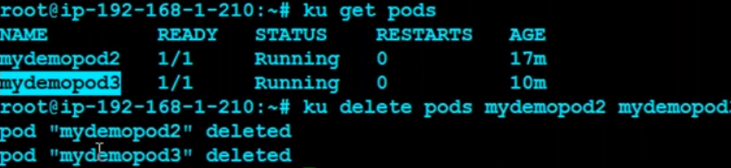

## Create a service with multiple configurations(---) in yaml

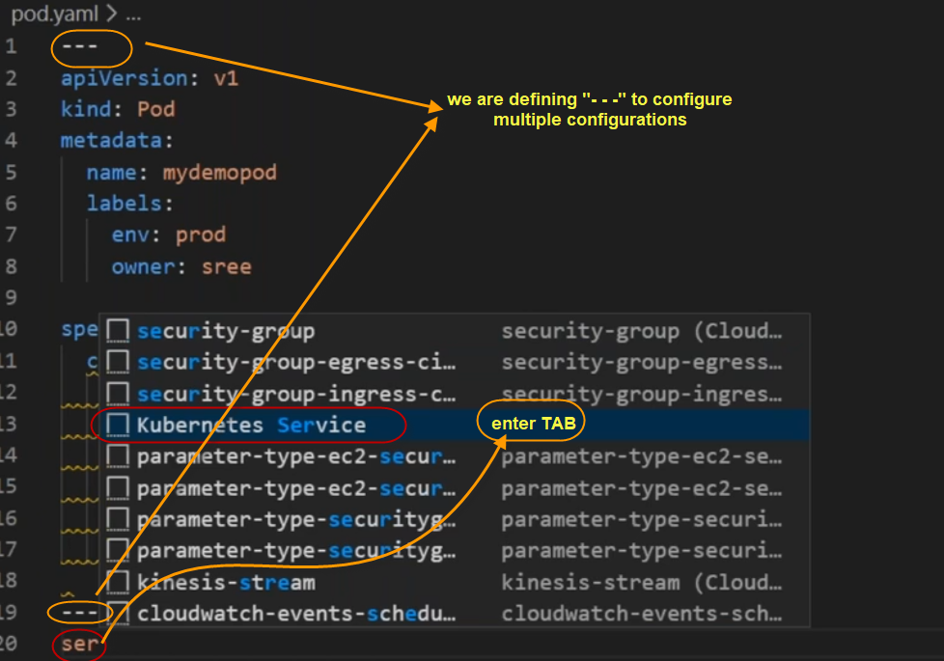

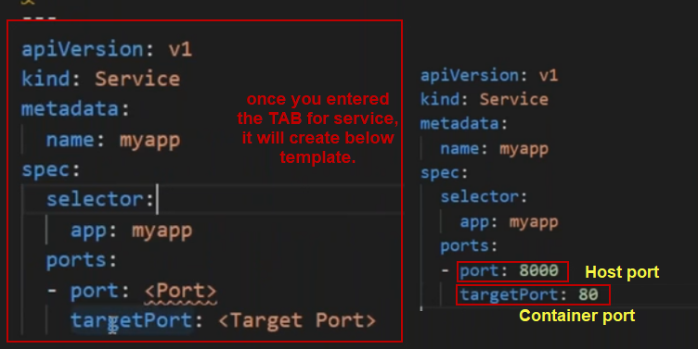

So now lets create a newpod.yml

$ nano newpod.yml

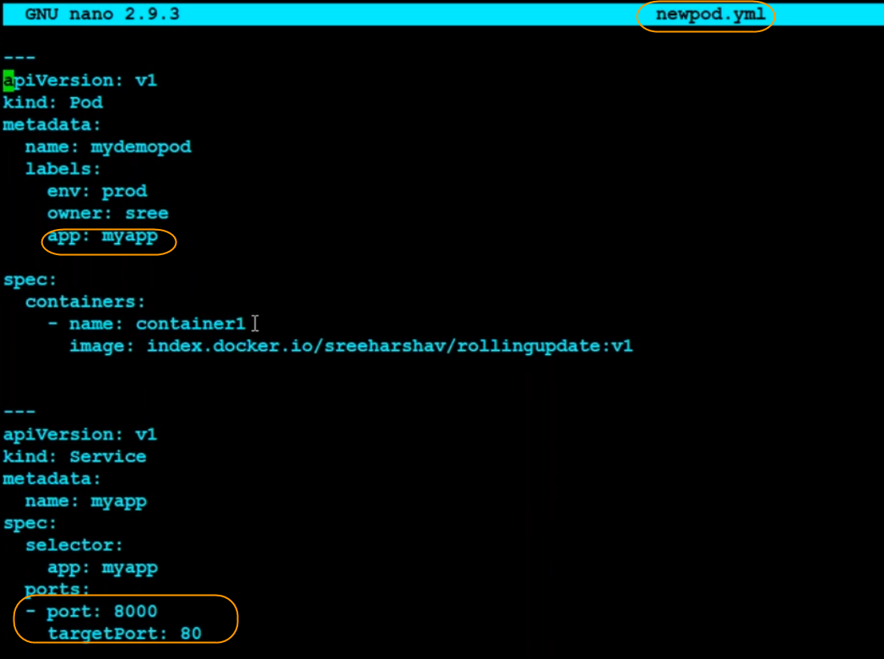

$ ku apply –f newpod.yml

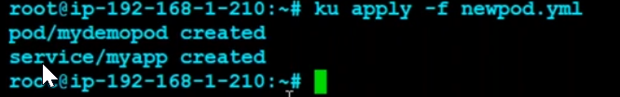

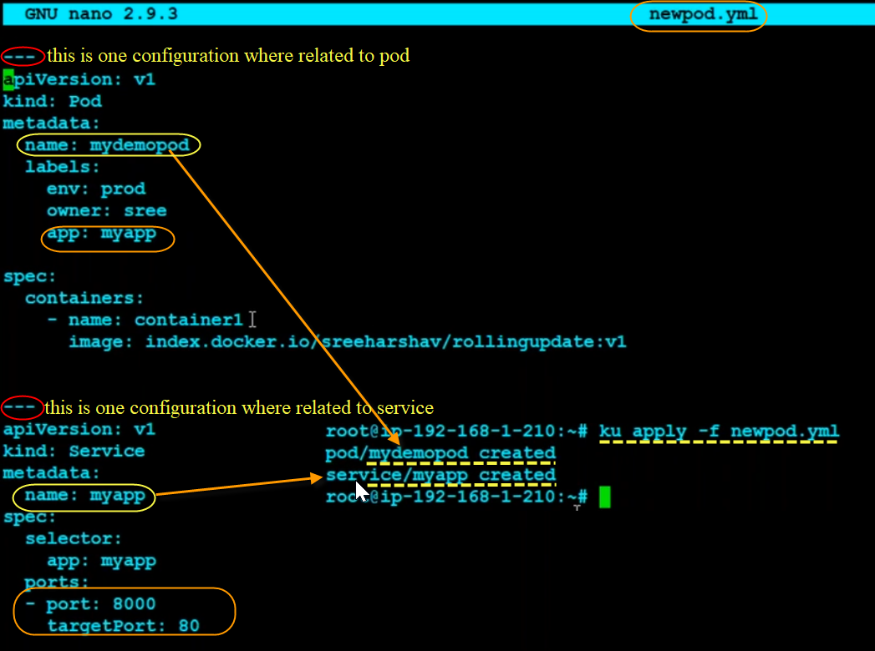

Here in above snapshot , our indentation is not good. So please correct your indentation as follows below.

<https://matthewpalmer.net/kubernetes-app-developer/articles/service-kubernetes-example-tutorial.html>

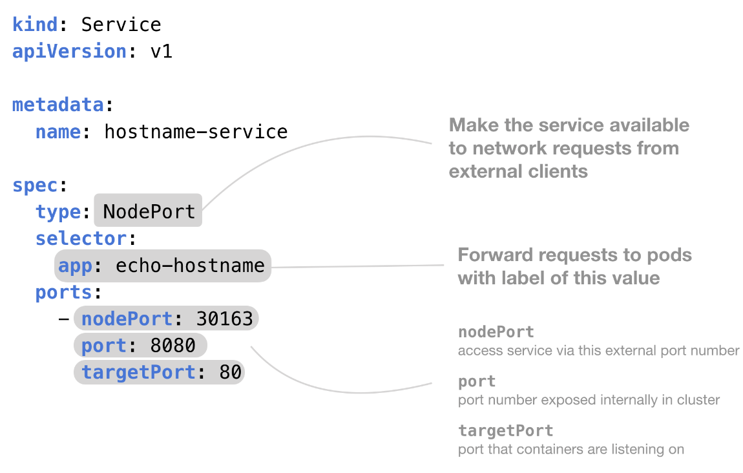

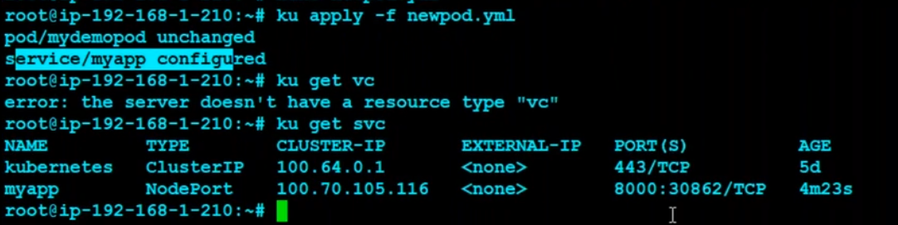

## Port range can be defined in kubernetes pod

The default range will be 30000 to 32000.

If you want to increase the range, you can increase the range only not the port no.

It’s a hectic work, why we need to configure, already kubernetes will take care of it.

## Kuberenetes service match labels with Selector

Here in above case , it is not able to connect with 30862 ,a because of our wrong configurations on yaml

It should be connect based on labels.

### Note:

* Make sure your labels should be unique.
* Please check the endpoint of your pod and services to check whether the labels are connected properly or not.

Google: “kuberenetes service match labels”

<https://kubernetes.io/docs/concepts/services-networking/connect-applications-service/>

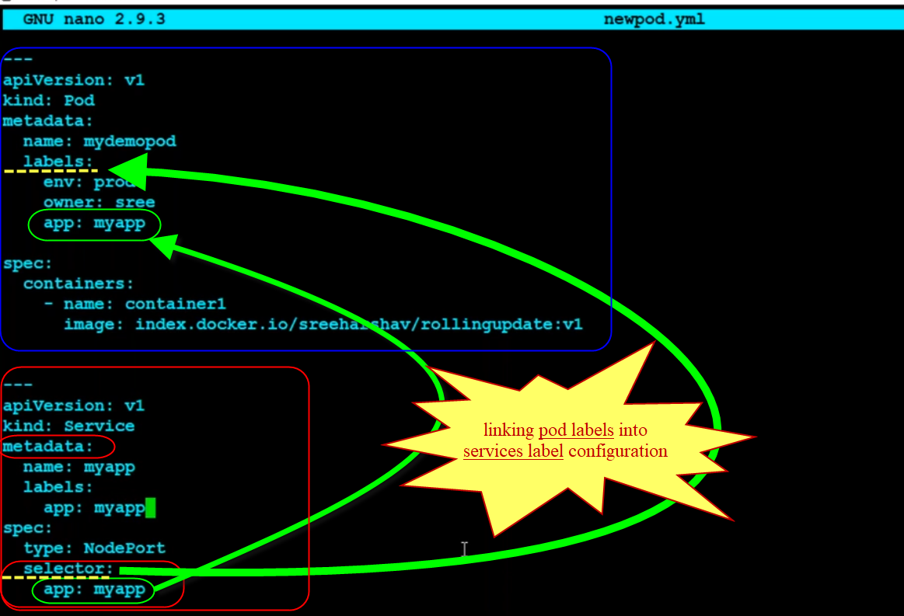

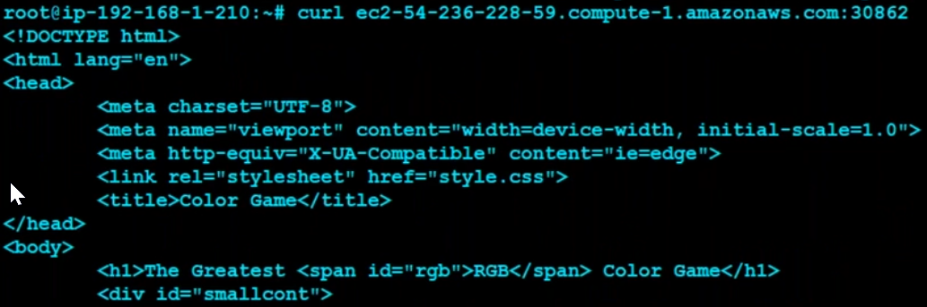

Now we are able to access.

## To check the pods logs

$ kubectl get pods

$ kubectl logs mydemopod2

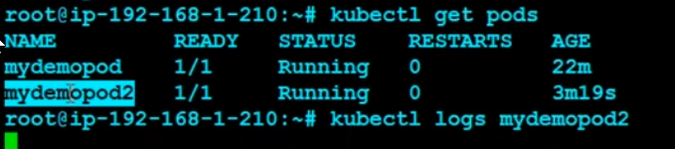

Output:

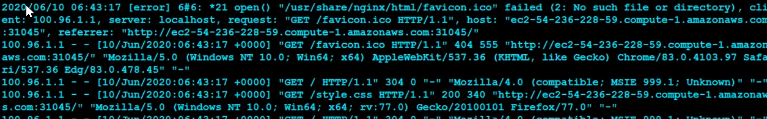

# Kubernetes cheatsheet

<https://kubernetes.io/docs/reference/kubectl/cheatsheet/>

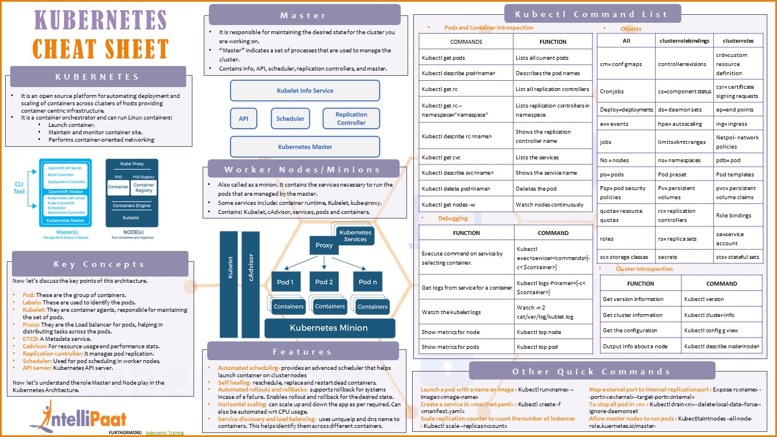

## CLI tools

# CLI setup

https://ibd.sh/**kubectl**

https://ibd.sh/**kubectx**

https://ibd.sh/**kubetail**

[https://ibd.sh/**helm**](https://ibd.sh/helm)

## contexts

# List available contexts

kubectx

# Change context to dev

kubectx dev

## namespaces

# List namespaces

kubens

# Change namespace to prod

kubens prod

# Create namespace test

kubectl create ns test

## ingress / manifest

# Ingress manifest example

apiVersion: networking.k8s.io/v1

kind: Ingress

metadata:

name: test-ingress

spec:

rules:

- host: foo.bar.com

http:

paths:

- path: /testpath

backend:

service:

name: test

port:

number: 80

tls:

- hosts:

- foo.bar.com

secretName: foobar-tls

## deploy / expose # Create a deployment named web, using image nginx into prod namespace

kubectl create -n prod deploy web --image=nginx

# Expose port 80 of deployment web with an internal service named front

kubectl expose deploy/web --port=80 --name=front

# Retrieve logs of pods with tag app=web

kubetail -l app=web

# Open a tunnel listening on 127.0.0.1:8080 to the port 80 of a pod related to deployment web

kubectl port-forward deploy/web 8080:80

# Create a Yaml manifest, without sending it to the cluster

kubectl create deploy web --image=nginx --dry-run=client -o yaml > web.yml

# Edit deployment web

## kubectl edit deploy/web

## help / debug

# Retrieve detailed state of pod test

kubectl describe pod test

# Get all possible attributes of a resource

kubectl explain pod --recursive

# Open a bash terminal in pod app

kubectl exec -it app -- bash

# NB : The flag --help provide help of any command

## storage / volume

# PVC manifest example

kind: PersistentVolumeClaim

apiVersion: v1

metadata:

name: web-data

spec:

accessModes:

- ReadWriteOnce

resources:

requests:

storage: 42Gi

## configuration

# Use the config file /path/to/config rather than ~/.kube/config

export KUBECONFIG=/path/to/config

# Merge two configuration files config1 and config2 in one file config

KUBECONFIG=config1:config2 kubectl config view --flatten > config

# Export only the current context configuration to file config

kubectl config view --minify --flatten > config

# Kubernetes important books

<https://matthewpalmer.net/kubernetes-app-developer/articles/service-kubernetes-example-tutorial.html>

please get the matthewpalmer book for kubernetes

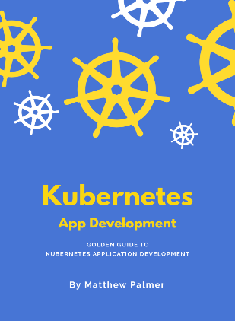

# Github kops for any kubernetes documentaitons

<https://github.com/kubernetes/kops>

<https://github.com/kubernetes/kops/tree/master/docs>

# How to create kops cluster with multiple zones.

<https://kops.sigs.k8s.io/cli/kops_create_cluster/>

most useful link, with all commands and explanation in details.

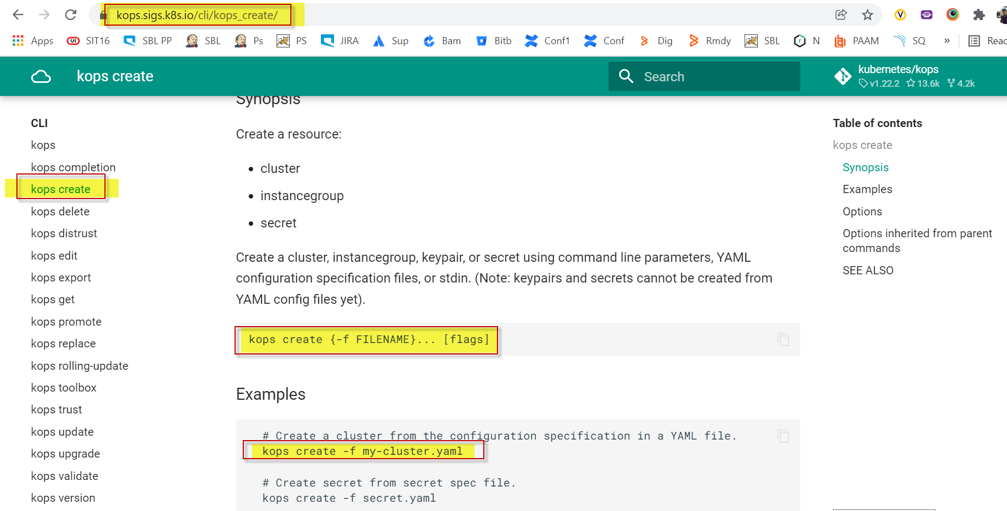

# Difference between kubectl and minikube

* Minikube is gives the cluster
* Kubectl is to manage minikube cluster
* Minikube will work as a management server. This is only for simulation of your pods.

It will not use for pod replicas, because we have only one server. We will use for minikube whether our yaml file is working fine or not.

* **Kubeadm** is a tool to get Kubernetes up and running on already existing machine. ... But you need to prepare the machines your self (install OS + required software, networking, ...). kubeadm will not do it for you.
* **Minikube** is a tool which will allow you to start locally single node Kubernetes cluster.
* **kops** builds the **EC2** instances for you, and can also build **VPC**, **IAM**, **Security groups** and a number of other features as well. If you need **HA masters** or **manifest-based cluster** management, then kops may also be your first choice.

1. **Kubeadm** is a tool to get Kubernetes up and running on already existing machine. It will basically configure and start all required Kubernetes components (for minimum viable cluster). Kubeadm is the right tool to bootstrap the Kubernetes cluster on your virtual machines. But you need to prepare the machines your self (install OS + required software, networking, ...). kubeadm will not do it for you.
2. **Minikube** is a tool which will allow you to start ~~locally single node~~ Kubernetes cluster. This is usually done in a VM - minikube supports VirtualBox KVM and others. It will start for you the virtual machine and take care of everything. But it will not do a 4 node cluster for you.
3. **Kubeadm** takes care of both. You first setup the master and then use kubeadm on the worker nodes to join the master.
4. When you use Kubeadm, it doesn't really care what do you use for the virtualization. You can choose whatever you want.
5. Why do you want to run virtual machines on top of your EC2 machine? Why not just create more (perhaps smaller) EC2 machines for the cluster? You can use this as an inspiration: <https://github.com/scholzj/terraform-aws-kubernetes>. There are also some more advanced tools for setting up the whole cluster such as (for example) [Kops](https://github.com/kubernetes/kops/).

# Kubernetes Traffic Flow

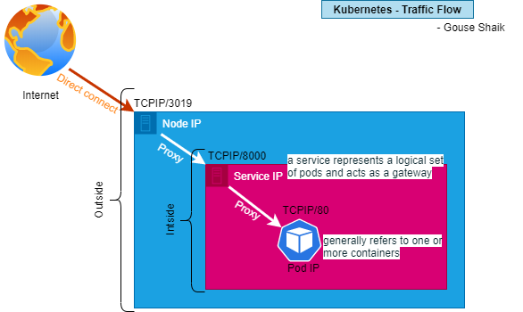

# MINIKube on AWS EC2

## MINIKUBE is just for testing and will not come with full-fledged one.

sudo apt-get update && sudo apt-get install -y apt-transport-https

curl -s https://packages.cloud.google.com/apt/doc/apt-key.gpg | sudo apt-key add -

echo "deb https://apt.kubernetes.io/ kubernetes-xenial main" | sudo tee -a /etc/apt/sources.list.d/kubernetes.list

sudo apt-get update

sudo apt-get install -y kubectl conntrack

curl https://get.docker.com | bash

curl -Lo minikube https://storage.googleapis.com/minikube/releases/latest/minikube-linux-amd64 && chmod +x minikube

sudo mv minikube /usr/local/bin

set NO_PROXY=localhost,127.0.0.1,10.96.0.0/12,192.168.99.1/24,192.168.39.0/24

minikube start --vm-driver=none

# Replication Controller

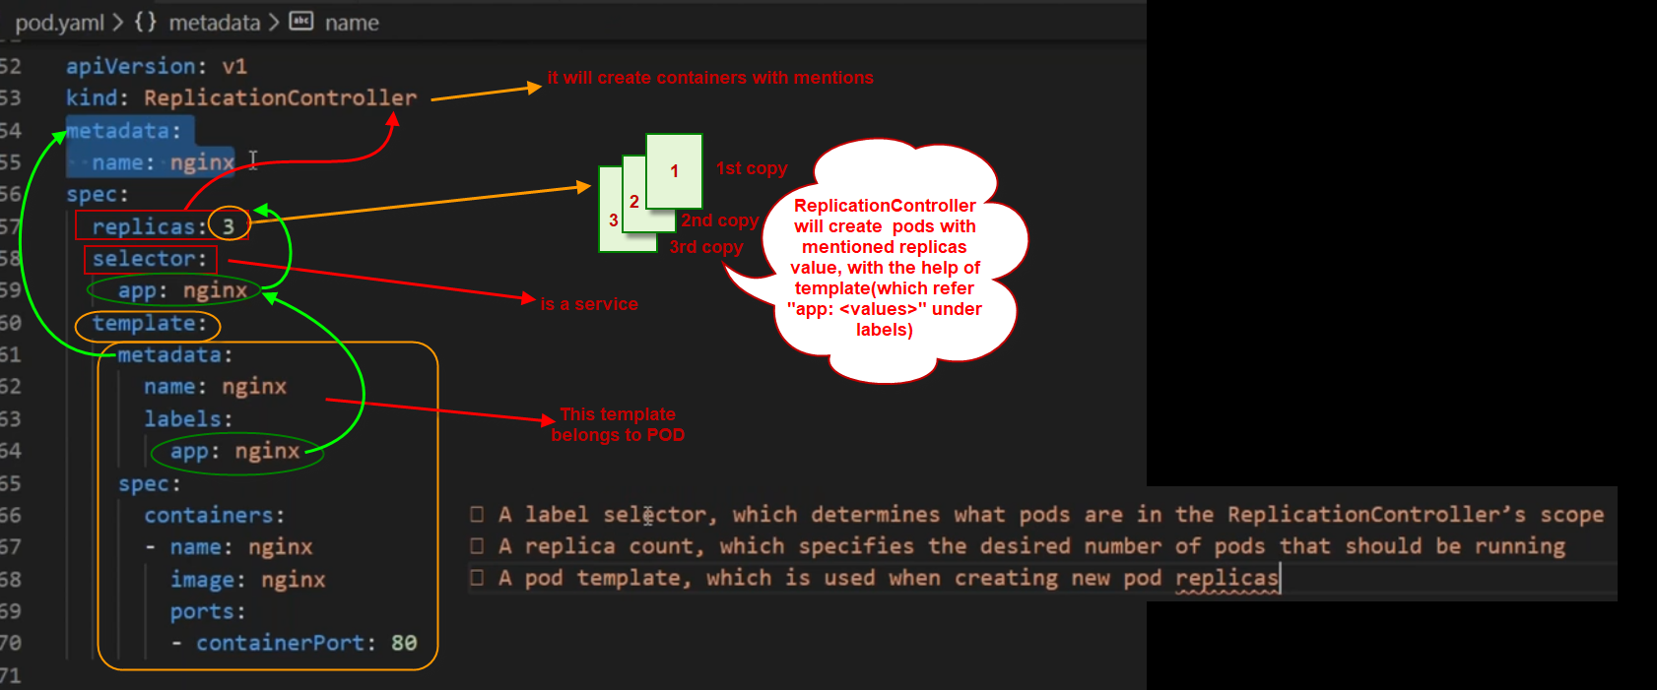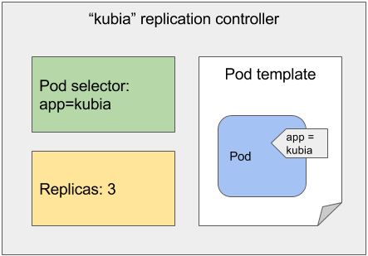

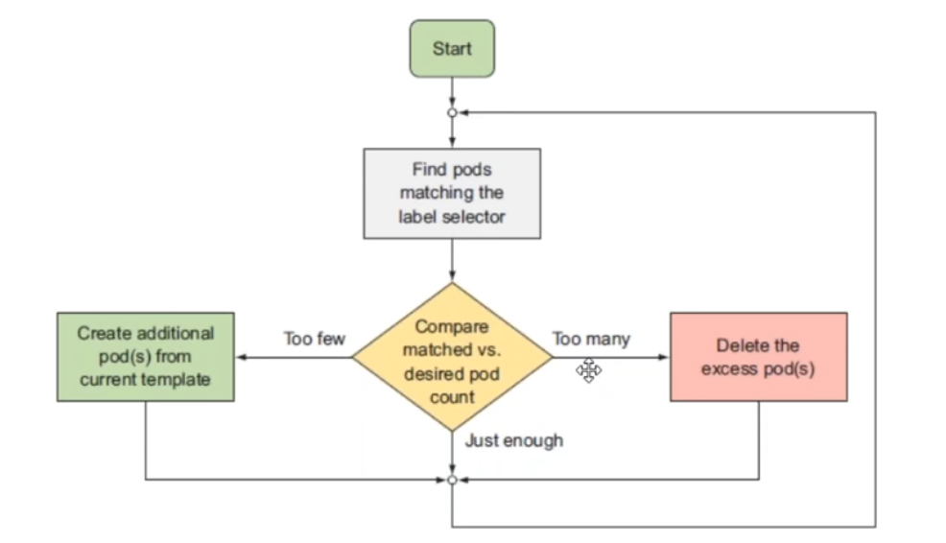

## Note:

Replicaitoncontroller is old one, so calling multiple lables will have an issues in replicationController.

This is the reason, replicaSet came into the picture. We can give multiple lables in replicaSet.

## 3 sections In kubernetes yaml file

1. Metadata ( we can control)
2. Specification ( we can control)
3. Status(it will be taken care by kubernetes)

Vi rc.yml

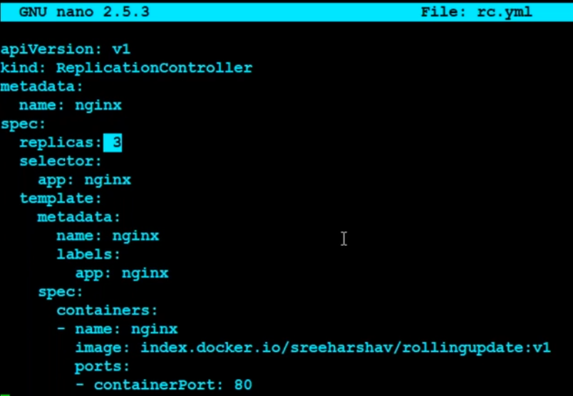

# kubectl apply -f rc.yml



#ku get pods

#ku get rc

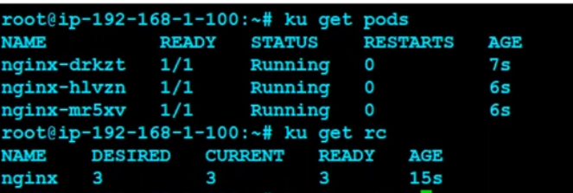

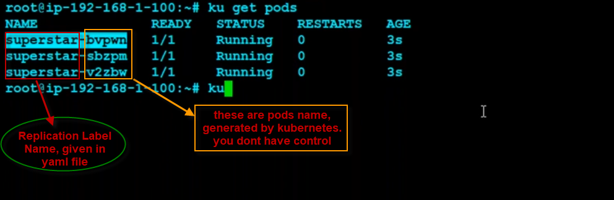



# Metadata section in pod yaml

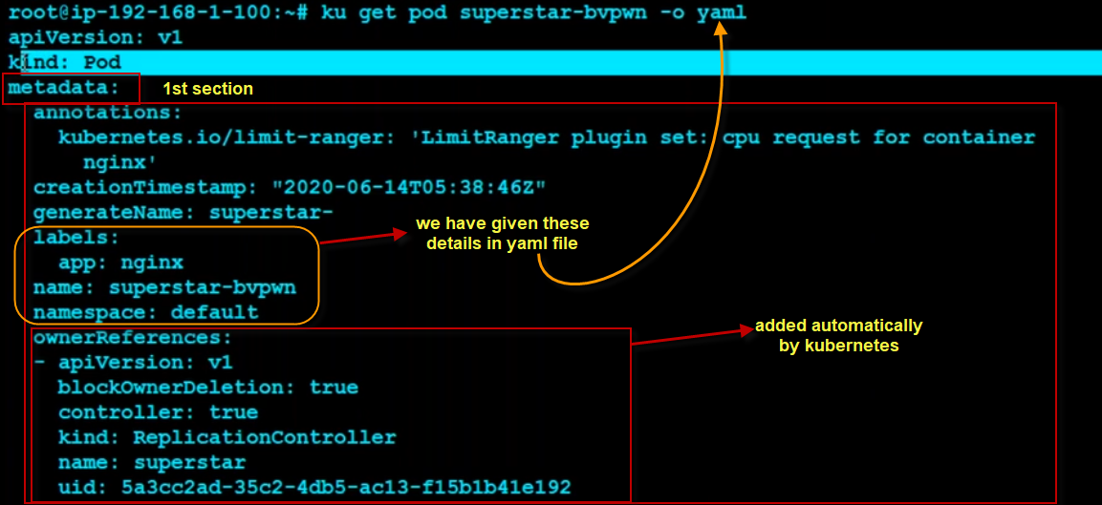

# Specification section from pod yaml

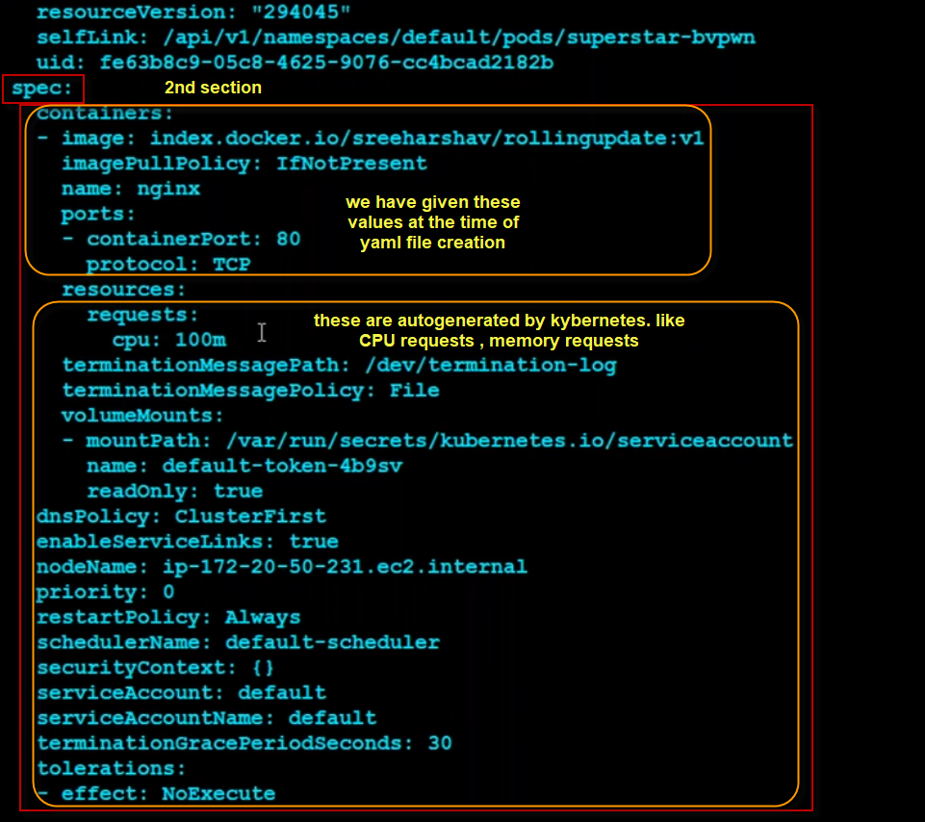

# Status section from pod yaml

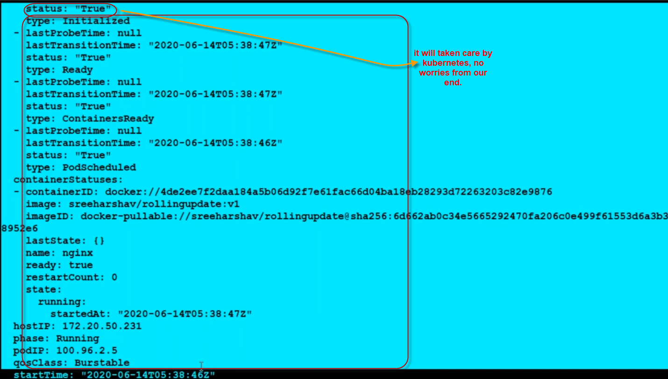

## Note:

replicationController become old, so we will not work in realtime, so we will go for new component like replicaSet.

# Adding pods and removing pods with the replication controller

## Lets add one more pod.

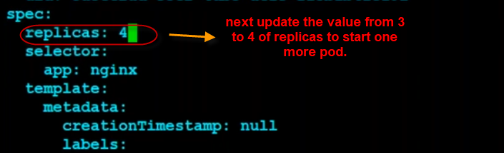

One more pod added.

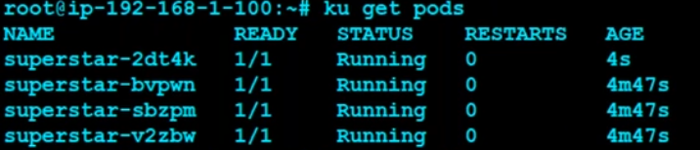

i.e; superstar-2dt4k pod.

## How can we do this 4k pod should not be managed by replicationController

Lets show the labels, because everything will work on labels

# ku get pods --show-labels

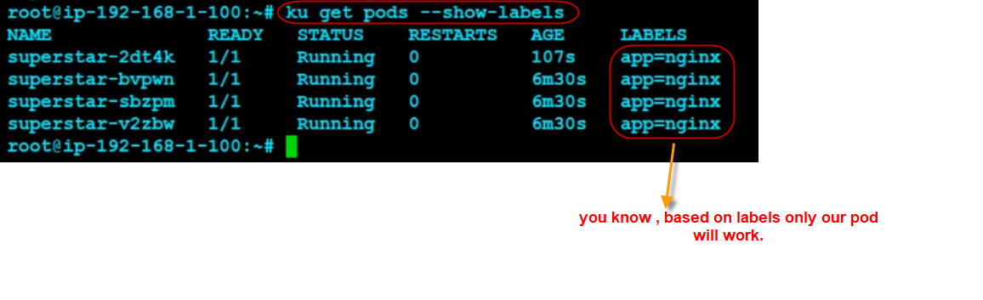

## To remove pod from replication

# ku label pod superstar-2dt4k app-



## To watch the status of pods

# watch –n 1 kubectl get pods –show-labels



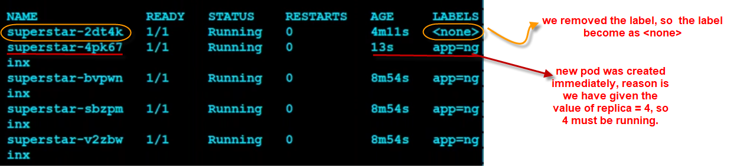

## To enter inside the pod or reconfigure or to check the pod of 4k

#ku exec --it superstar-2dt4k -- bash

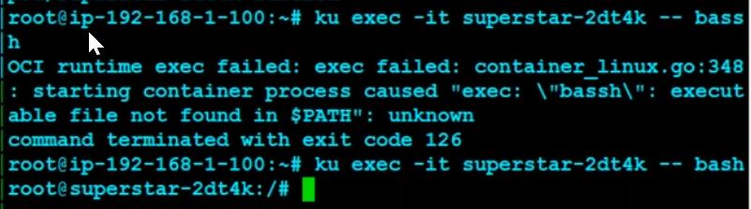

## Now get back your 4k pod by adding a label to it

# ku label pod superstar-2dt4k app=nginx

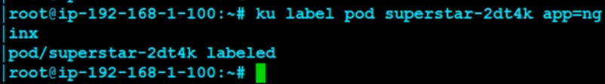

## To re-watch the status of pods

# watch –n 1 kubectl get pods –show-labels

You can see now one pod has been terminated by replacing our labeled pod.

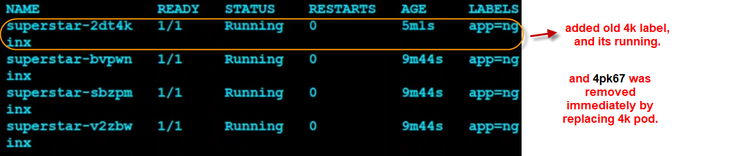

## Delete the replication controller

# kubectl delete replicationcontroller {replicationController}

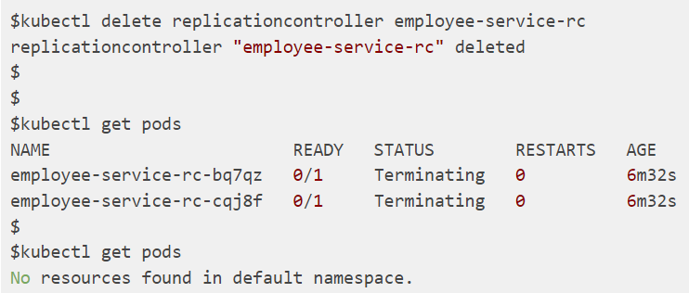

## Kubectl run for deployment not for a pod

# kubectl run ……

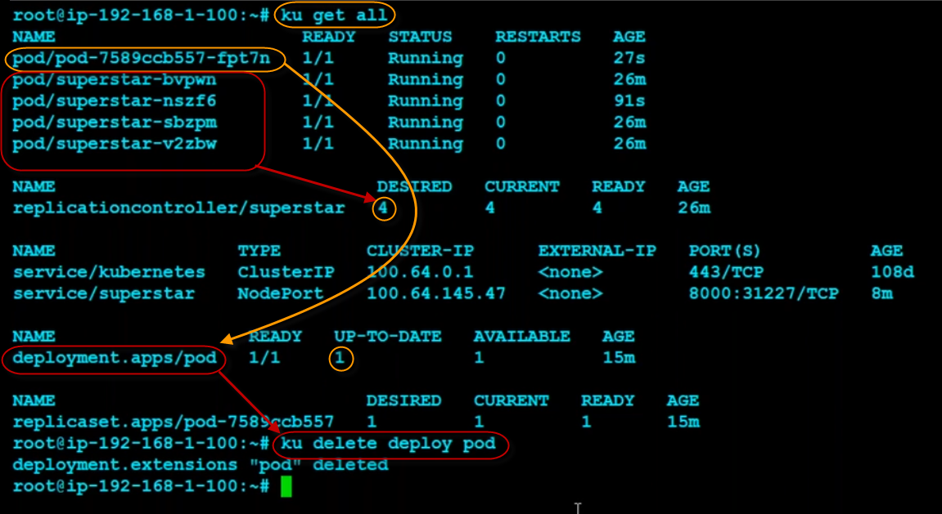

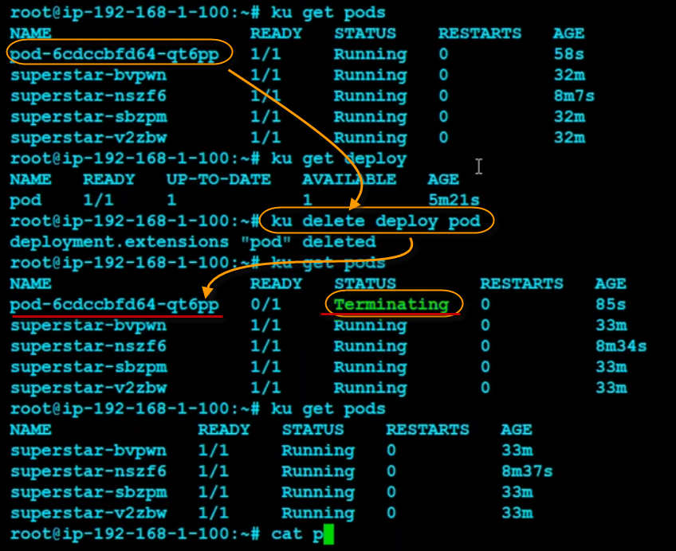

Note: rarely we will run an individual pod



# ku run –generator=run-pod/v1 testpod –image=index.docker.io/sreeharshav/rollingupdate:v3

# ku get pods

# ku delete pod testpod

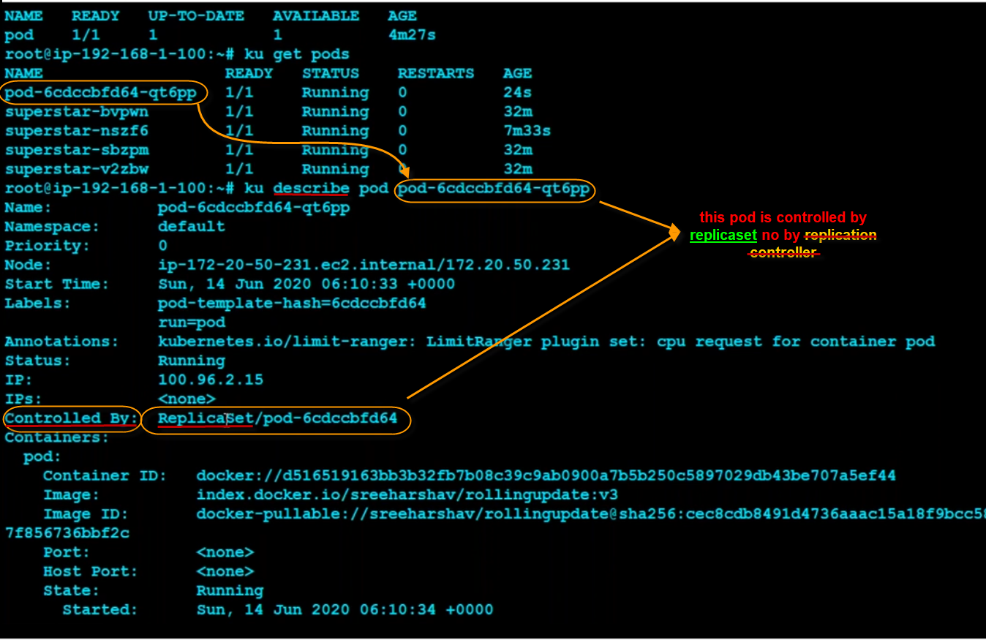

## To get the deploy details

# kubectl get deploy

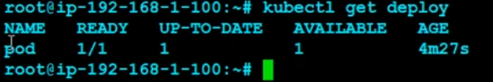

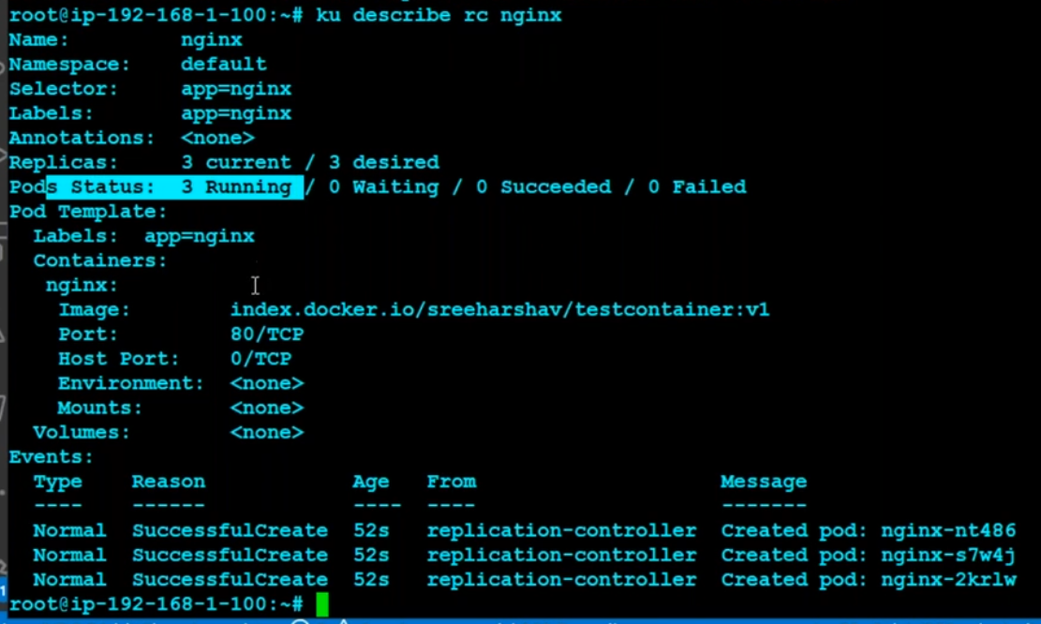

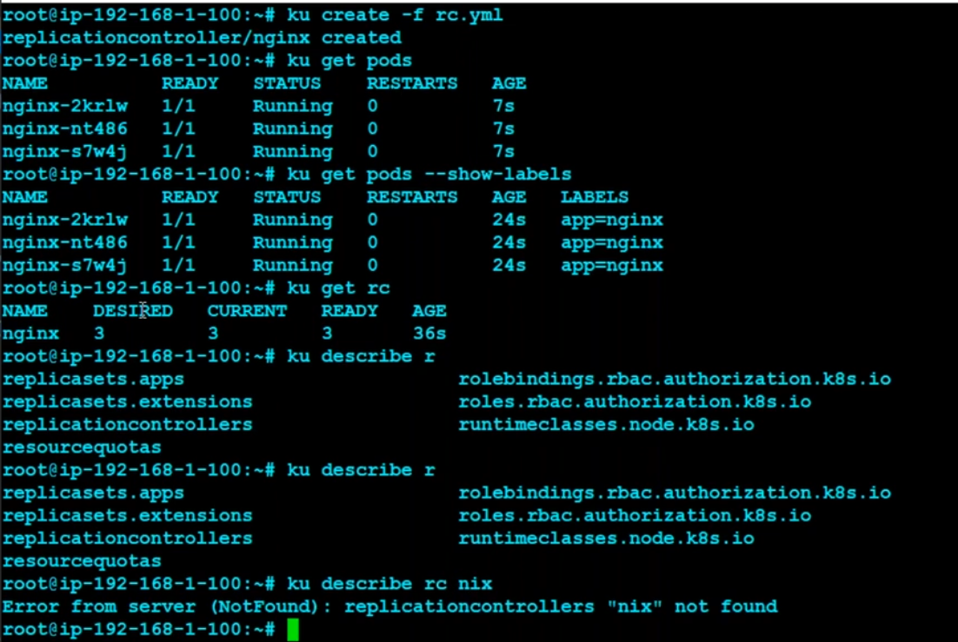



## Note:



# Replication Set

It will works same as replication controller, additionally it will have the options matchLabels: and matchExpression set

The replica set are also known as next generation replication controller.

## In old versions

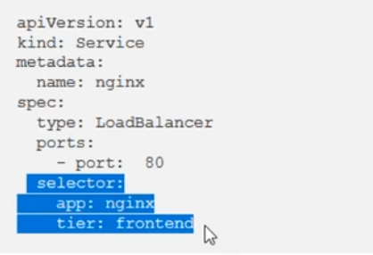

## replicaSet with matchLabels and matchExpressions in new versions

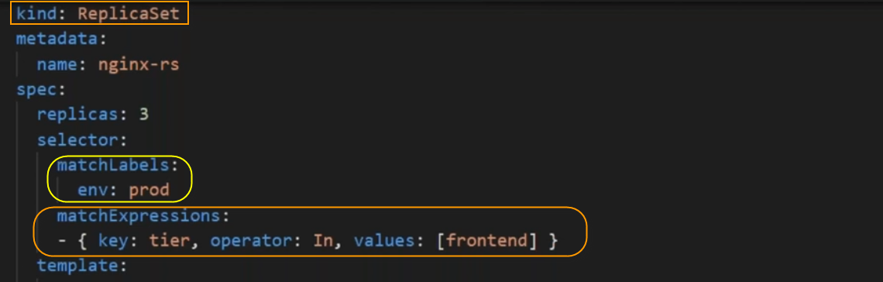

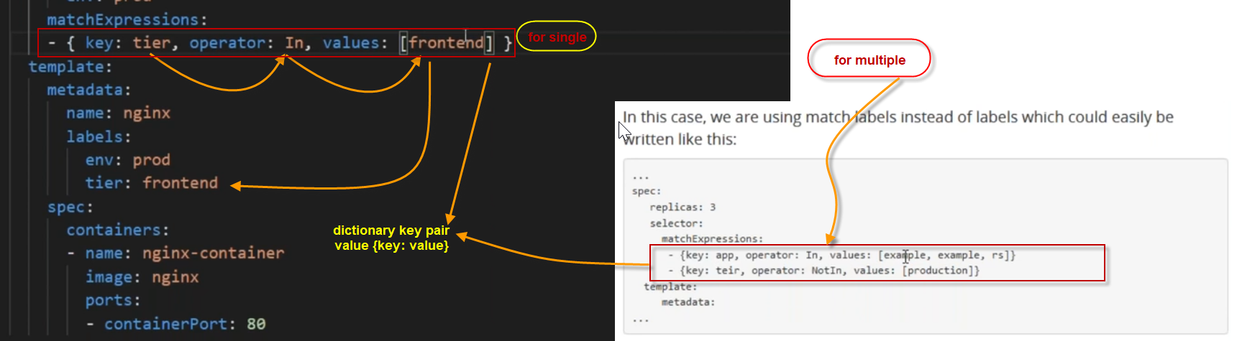

## Key pair value calling mechanism

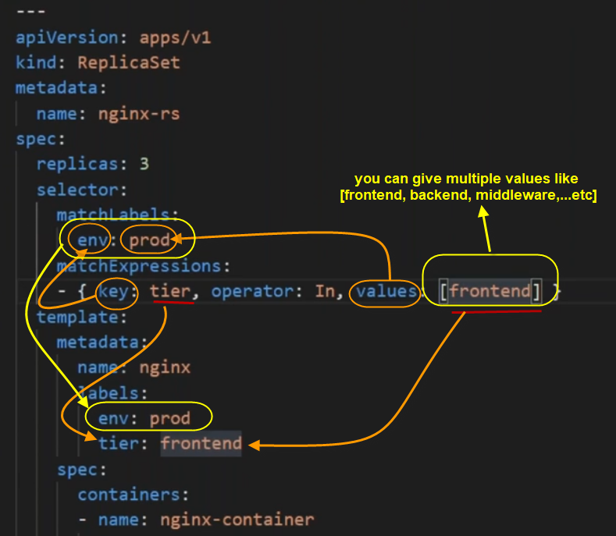

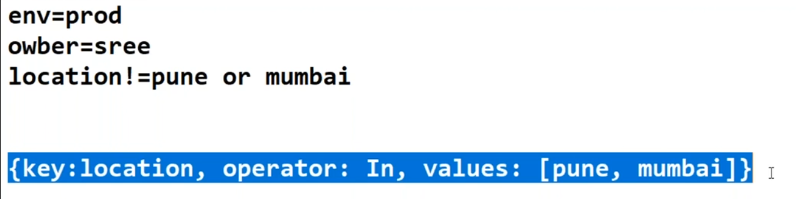

# Updating pods – rolling updates

## This is one method

There is no change in replication controller, only change in pod template.

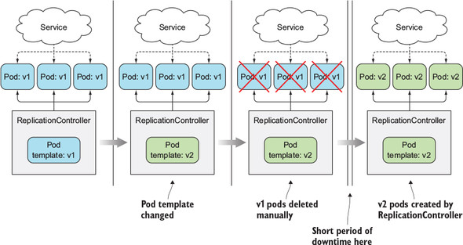

## This is blue-green method

Switching from the old to the new version at once (Blue-Green), all traffic going to service via DNS. With the new replication controller. Just we will migrate to existing service. We will move traffic to different environments

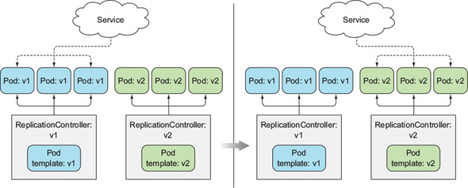

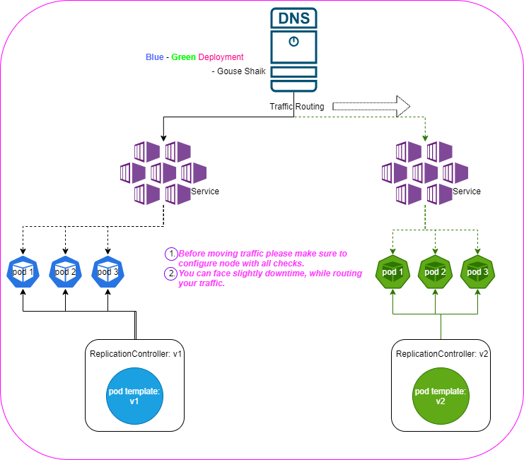

## Rolling update method

Old pod delete and new pod will create. We can do it with kubectl but we will face some issues. So we will not do it in realtime.

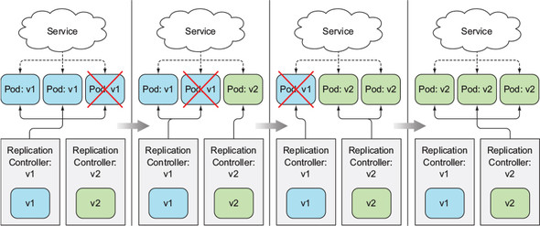

## Differences between Blue-green and Rolling update(zero-downtime)

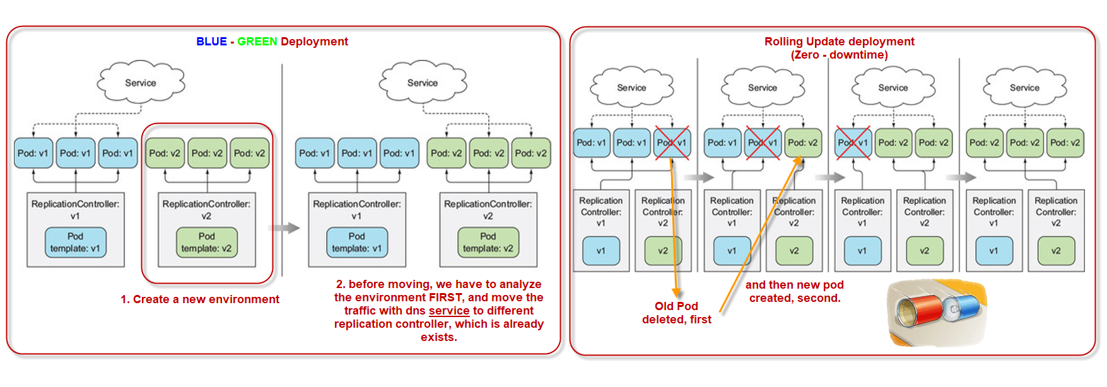

## Note:

rolling-update is deprecated, Please use rollout.

$ kubectl rollout --help

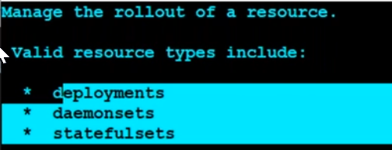

You can see replicationController was removed.

$ kubectl rolling-update superstar2 --image=index.docker.io/sreeharshav/testcontainer:v1

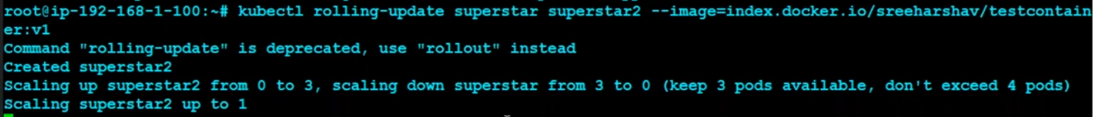

## Create a replication controller with 3 replicas



#ku create –f rc.yml

# Kubernetes service to check pods of replication controller

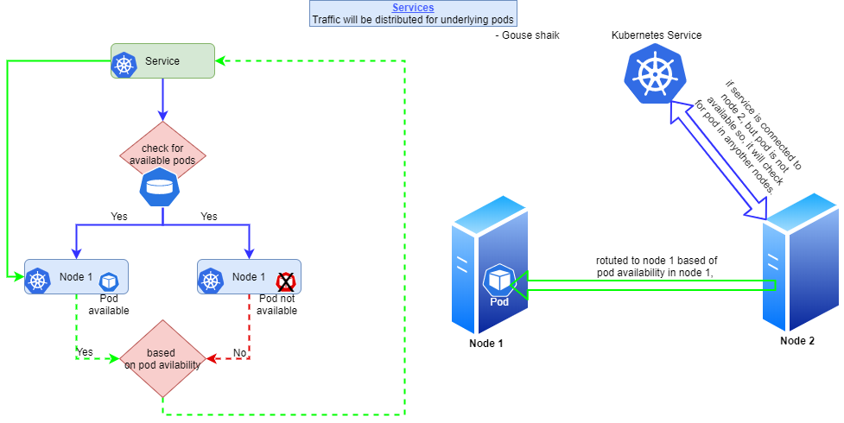

# In Deployment there are concepts list

## Rediness Probe

It will check whether the pod is started properly or not, if yes then only it will sends the traffic to the pod.

## Liveness Probe

It will continuously check like ping, html file accessing, etc… to check whether the pod is hang or not.when the liveness probe is stopped, then new container/pod will be created an your hung issue will be resolved.

USE THIS:

### Docker installation with curl command

curl https://get.docker.com | bash

sudo apt-get update && sudo apt-get install -y apt-transport-https curl

curl -s https://packages.cloud.google.com/apt/doc/apt-key.gpg | sudo apt-key add -

cat <<EOFecho | sudo tee -a /etc/apt/sources.list.d/kubernetes.list

"deb https://apt.kubernetes.io/ kubernetes-xenial main"

EOF

sudo apt-get update

sudo apt-get install -y kubelet kubeadm kubectl

sudo apt-mark hold kubelet kubeadm kubectl

kubeadm init --pod-network-cidr 192.168.0.0/16

# Creating a Deployment

Deployment in Kubernetes is a controller which helps your applications reach the

desired state, the desired state is defined inside the deployment file

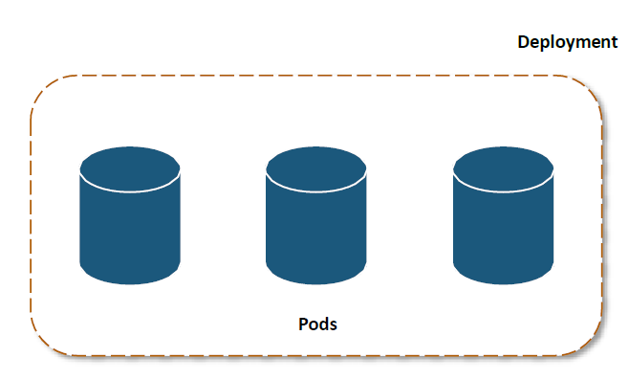

This YAML file will deploy 3 pods for nginx, and maintain the desired state which is 3 pods, until this deployment is deleted

apiVersion: apps/v1

kind: Deployment metadata:

name: nginx-deployment

labels:

app: nginx

spec:

replicas: 3

selector:

matchLabels:

app: nginx

template: metadata:

labels:

app: nginx

spec:

containers:

- name: nginx

image: nginx:1.7.9

ports:

- containerPort: 80

Once the file is created, to deploy this deployment use the following syntax:

# kubectl create –f nginx.yaml



## List the Pods

To view the pods, type the following command:

# kubectl get po



As you can see, the number of pods are matching with the number of replicas specified in the deployment file.

# Services

**Services** are used to load balance the traffic among the pods. It follows round robin distribution among the healthy pods

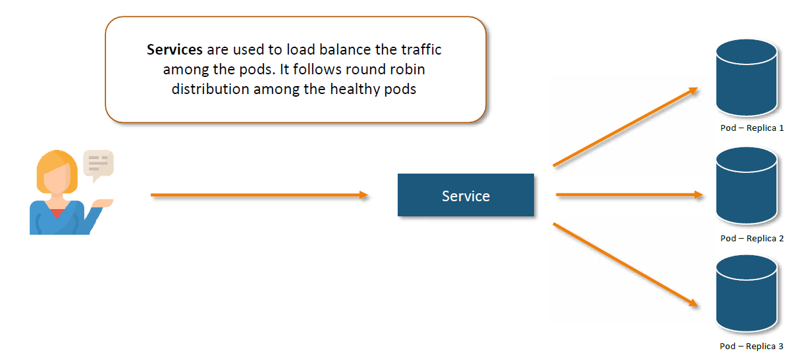

## Creating a service

A Service is basically a round-robin load balancer for all the pods, which match with it’s name or selector. It constantly monitors the pods, in case a pod gets unhealthy, the service will start deploying the traffic to the other healthy pods.

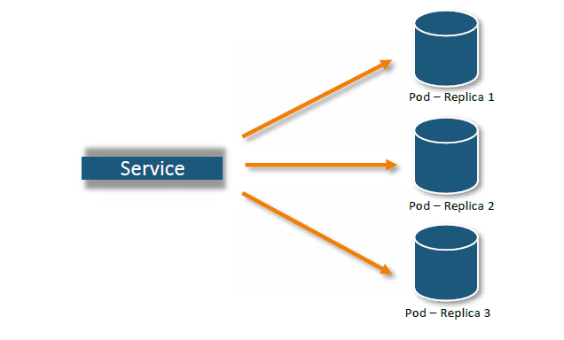

## Service Types

**ClusterIP:** Exposes the service on cluster-internal IP

**NodePort:** Exposes the service on each Node’s IP at a static port

**LoadBalancer:** Exposes the service externally using a cloud provider’s load balancer.

**ExternalName:** Maps the service to the contents of the ExternalName

## Creating a NodePort Service

We can create a NodePort service using the following syntax:

# kubectl create service nodeport <name-of-service> --tcp=<port-of-service>:<port-of-container>



# ingress

An **Ingress** is an object that allows access to your Kubernetes services from outside the

Kubernetes cluster. You configure access by creating a collection of rules that define which inbound connections reach which services.

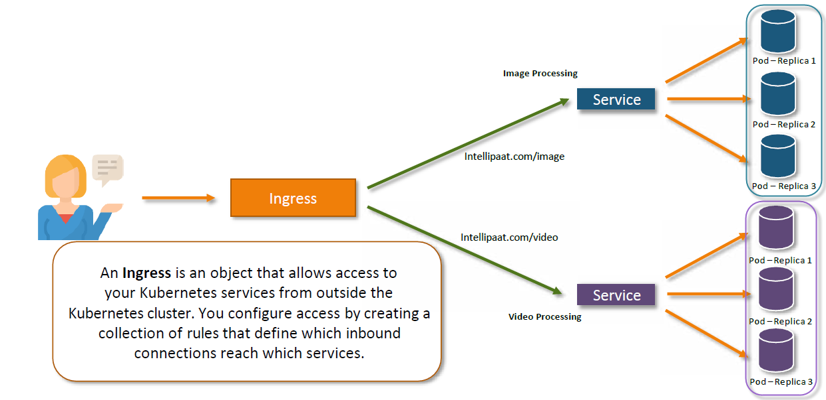

**Kubernetes ingress** is a collection of routing rules that govern how external users access services running in a Kubernetes cluster.

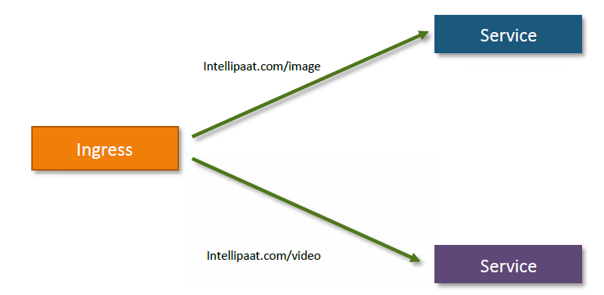

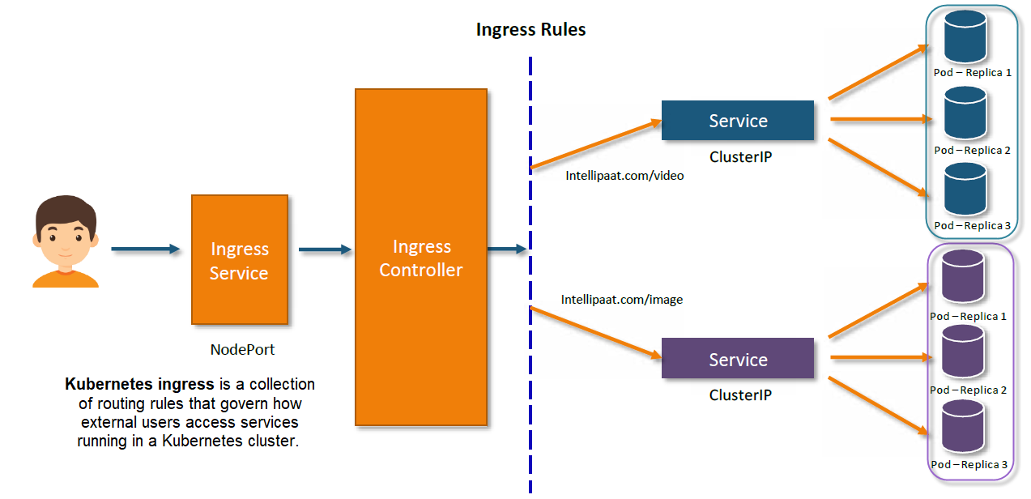

## Installing Ingress Controller

We will be using the nginx ingress controller, for our demo. We can download it from the following link:

<https://github.com/kubernetes/ingress-nginx/blob/main/docs/deploy/index.md>

### Define Ingress Rules

The following rule, will redirect traffic which asks for

/foo to nginx service. All the other requests, will be

redirected to ingress controller’s default page

apiVersion: extensions/v1beta1

kind: Ingress

metadata:

name: simple-fanout-example

annotations:

nginx.ingress.kubernetes.io/rewrite-target: /

spec:

rules:

- http:

paths:

- path: /foo

backend:

serviceName: nginx

servicePort: 80

### Deploying Ingress Rules

To deploy the ingress rules, we use the following syntax:

# kubectl create –f ingress.yaml



### Viewing Ingress Rules

To view the ingress rules, we use the following syntax:

# kubectl get ing



# Kubernetes Dashboard

Dashboard is a web-based Kubernetes user interface. You can use Dashboard to deploy containerized applications to a Kubernetes cluster, troubleshoot your containerized application, and manage the cluster resources.



## Installing Kubernetes Dashboard

To install Kubernetes Dashboard, execute the following command:

# kubectl create -f [https://raw.githubusercontent.com/kubernetes/dashboard/master/aio/deploy/recommended/kubernetes- dashboard.yaml](https://raw.githubusercontent.com/kubernetes/dashboard/master/aio/deploy/recommended/kubernetes-%20dashboard.yaml)



## Accessing Kubernetes Dashboard

Change the service type for Kubernetes-Dashboard to Nodeport

# kubectl -n kube-system edit service kubernetes-dashboard

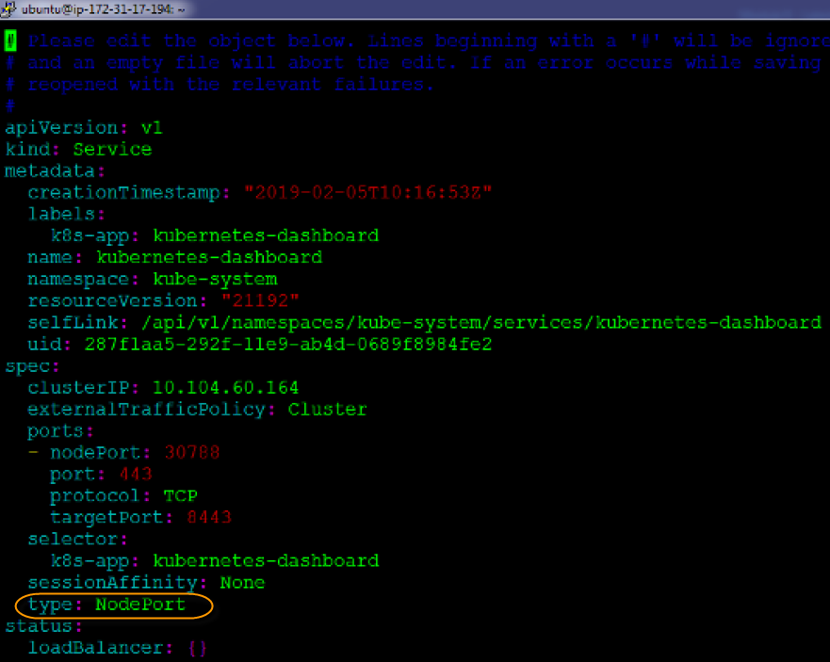

## Logging into Kubernetes Dashboard

1. Check the NodePort from the kubernetes-dashboard service

2. Browse to your cluster on the internet browser, and enter the IP address

3. Click on Token, it will ask you for the token entry

4. Generate a token using the following command

$ kubectl create serviceaccount cluster-admin-dashboard-sa

$ kubectl create clusterrolebinding cluster-admin-dashboard-sa \

--clusterrole=cluster-admin \

--serviceaccount=default:cluster-admin-dashboard-sa

$ TOKEN=$(kubectl describe secret $(kubectl -n kube-system get secret | awk '/^cluster-admin-dashboard-sa-

token-/{print $1}') | awk '$1=="token:"{print $2}')

$ echo $TOKEN

5. Finally, enter the token and login to your dashboard

# Kubernetes reference sites:

<https://kubernetes.io/docs/concepts/overview/working-with-objects/kubernetes-objects/>

<https://kubernetes.io/docs/reference/>

<https://kubernetes.io/docs/reference/generated/kubernetes-api/v1.22/>

## kubernetesbyexample for practice

<https://kubebyexample.com/en/concept/pods>

# Kuberntes Security

## Default Kubernetes native security

Default kubernetes give basic security.

## Kube-bench

is a tool that checks whether Kubernetes is deployed securely by running the checks documented in the CIS Kubernetes Benchmark.  
  
Installed Kube-bench and checks kubernetes cluster security.

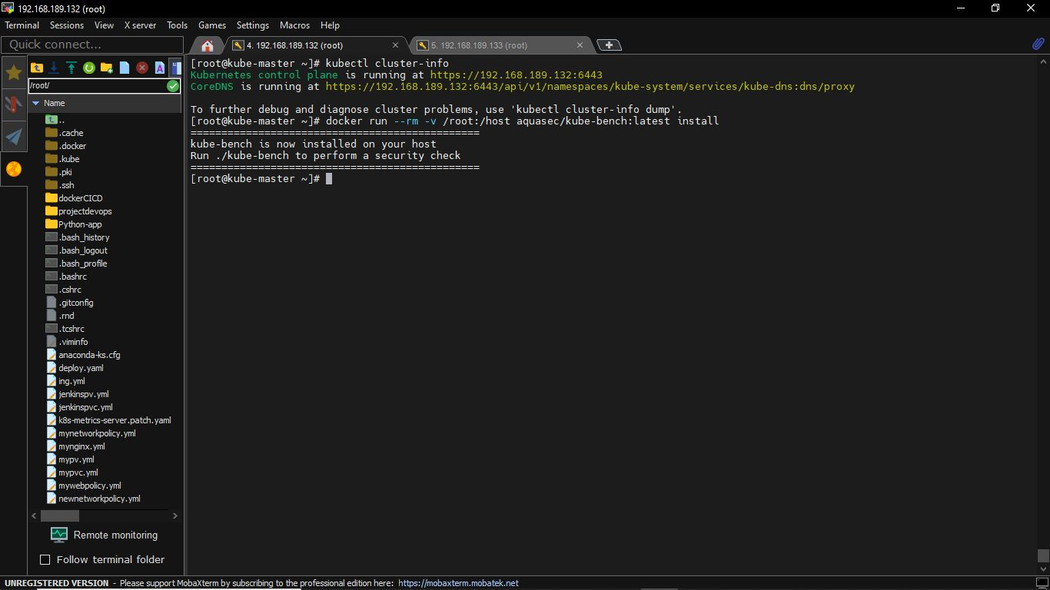

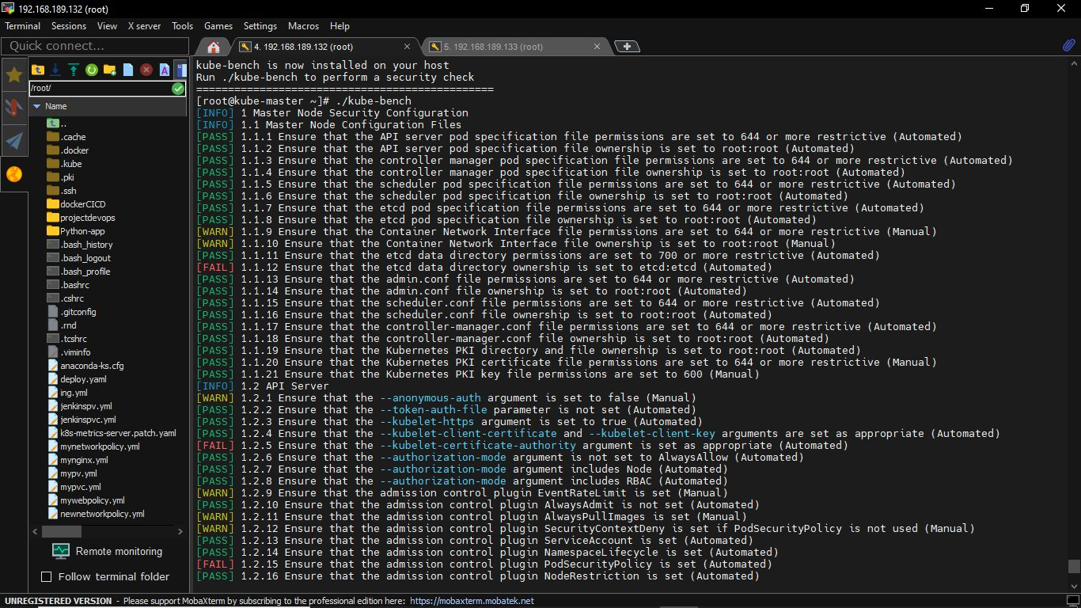

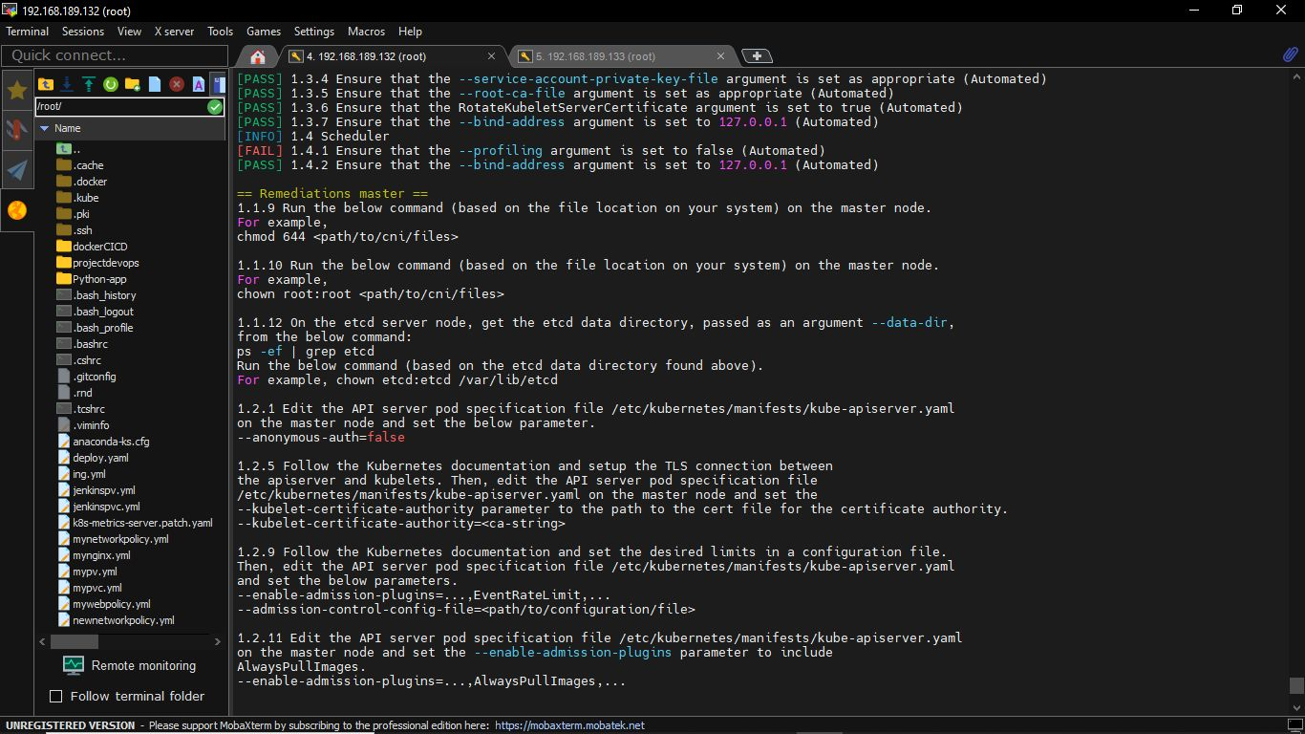

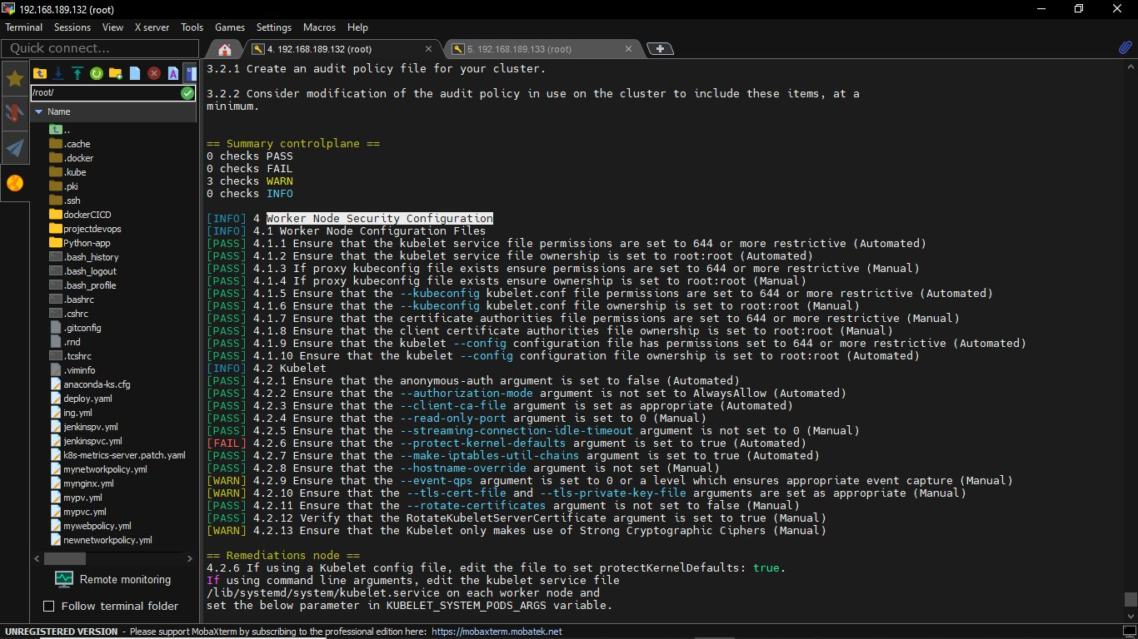

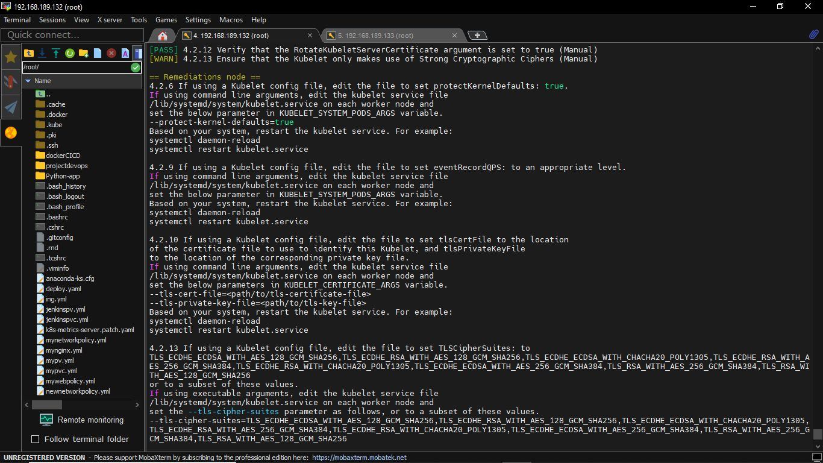

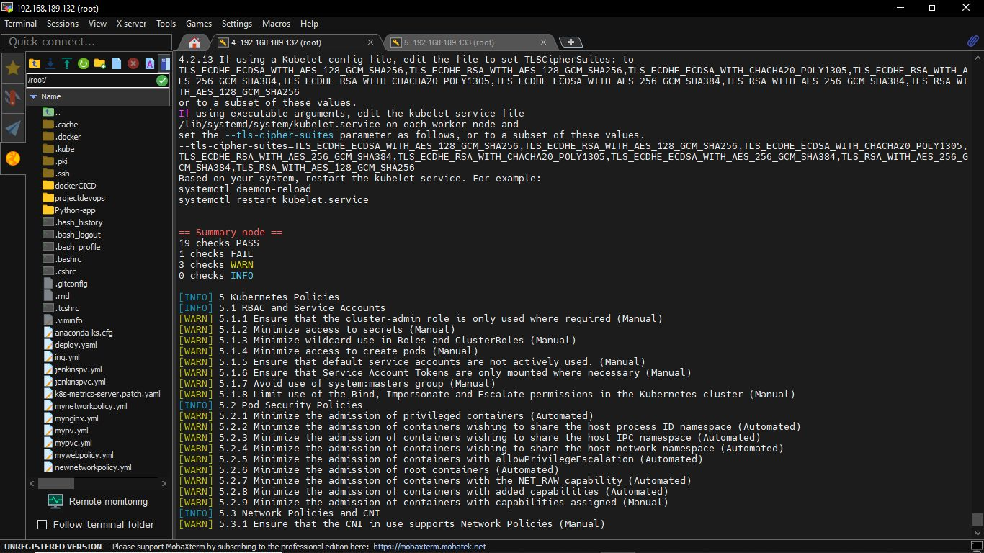

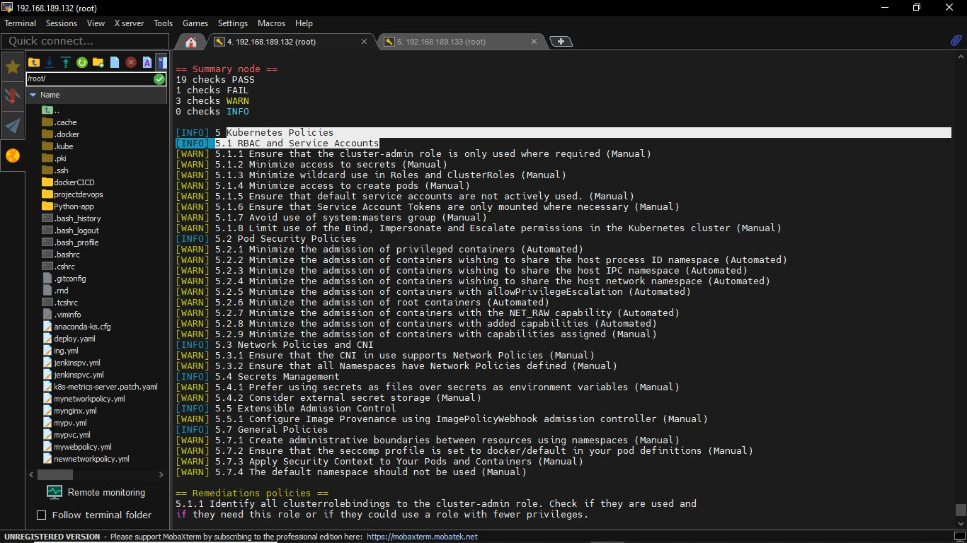

# Create an image in AWS

Now , my requirement is, I want one Ubuntu machine

Goto EC2 management console 🡪 launch instance

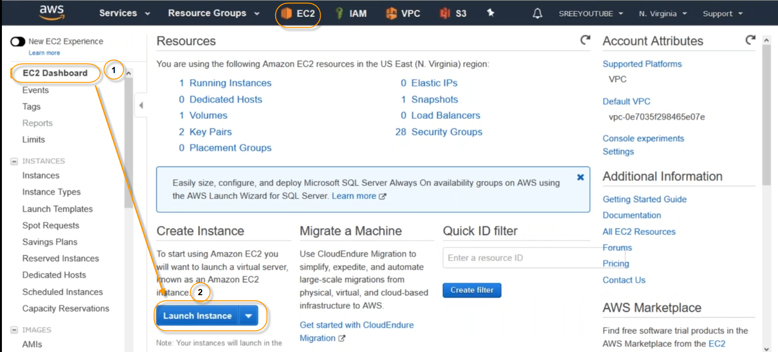

Select 16.04 , there is no support of kubeadm on 18.04

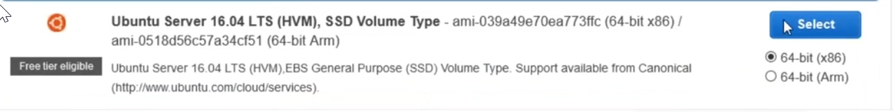

Select t2.micro

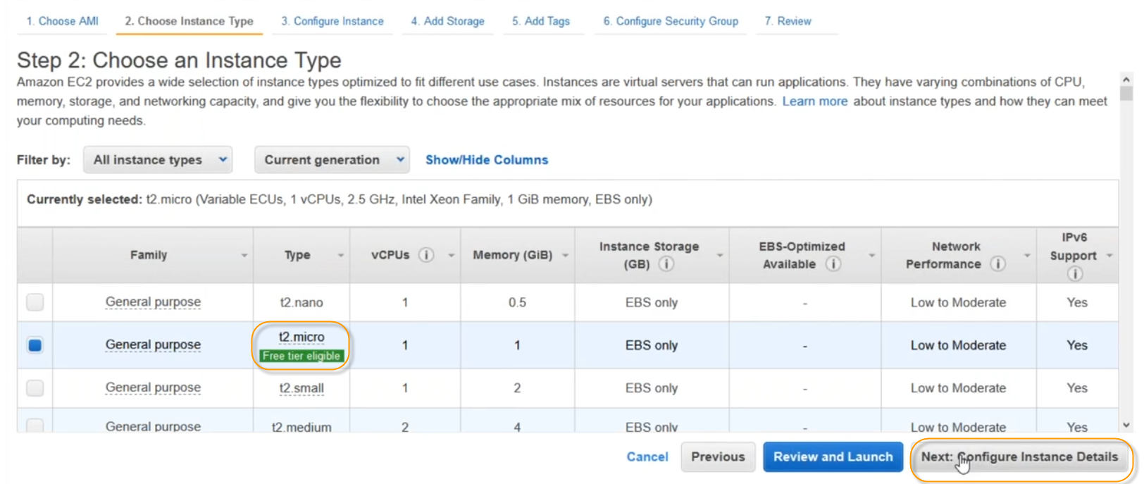

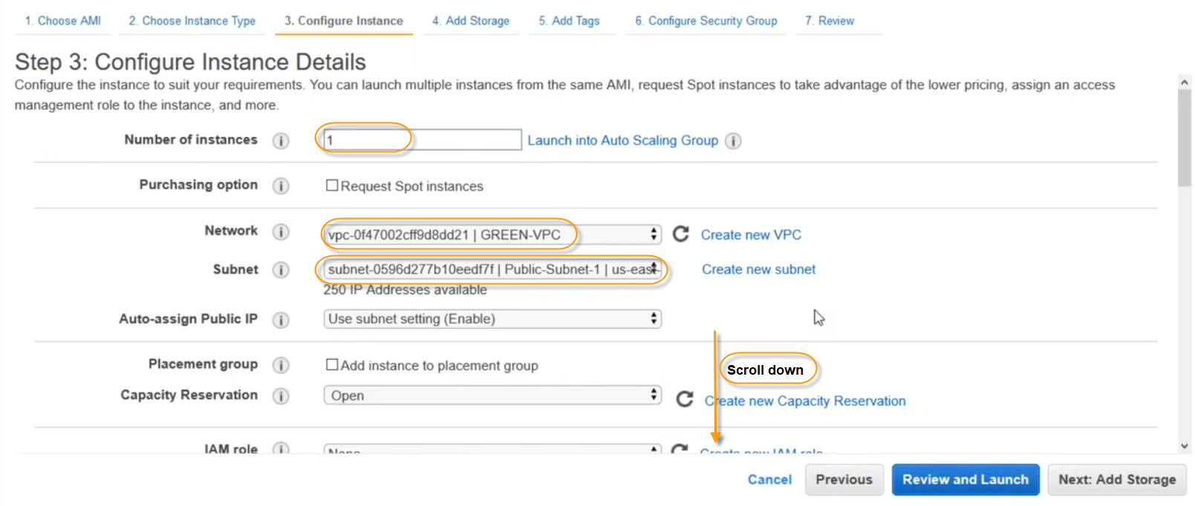

Copy this script

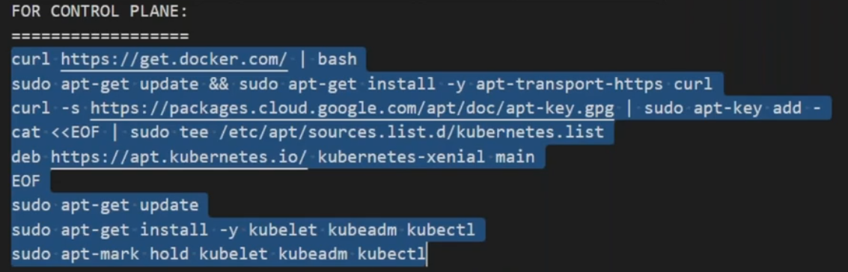

And add it in your bootstrap script

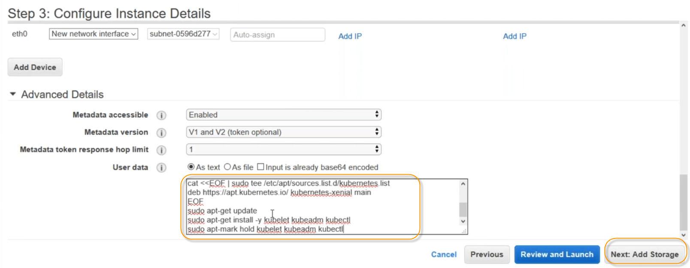

Click on Add storage, and click on “add new volume”

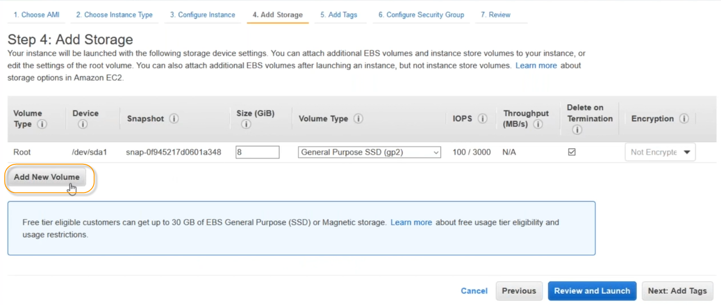

Click on “Add Tags”

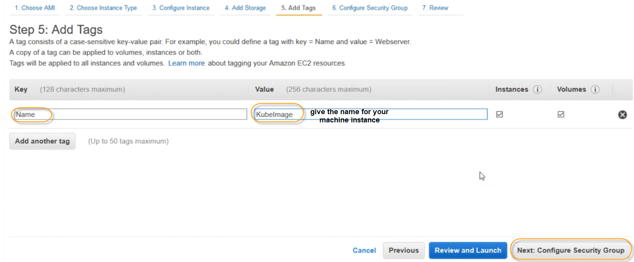

Click on Configure Security Group

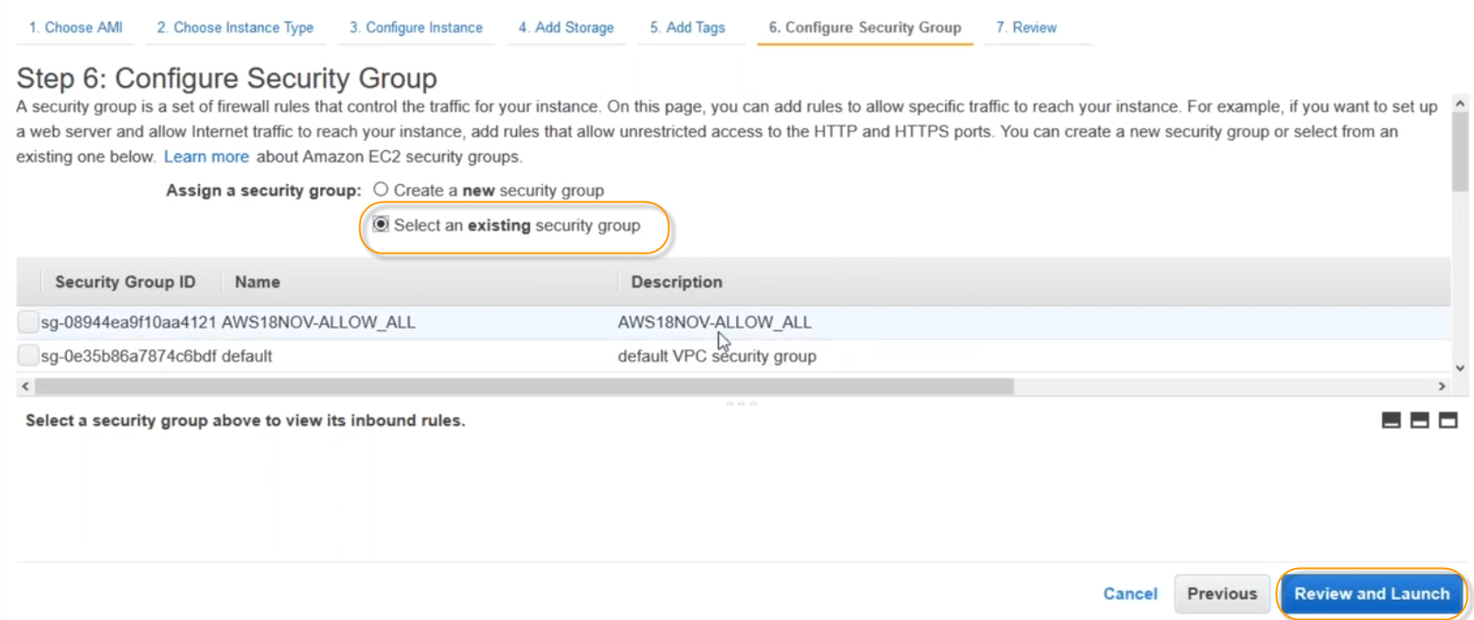

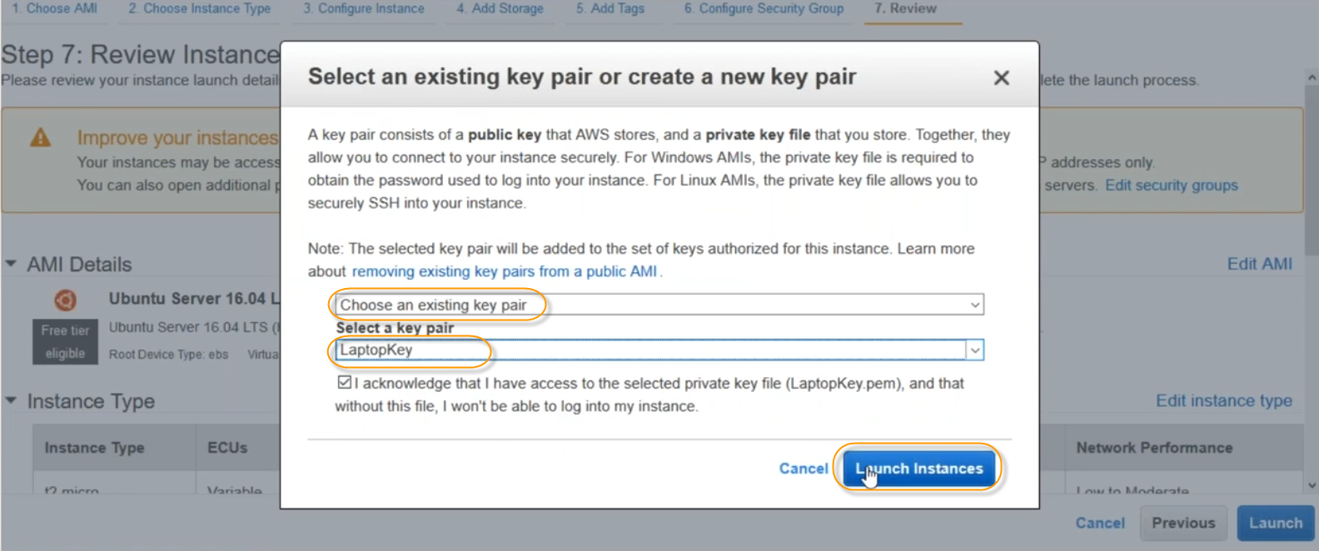

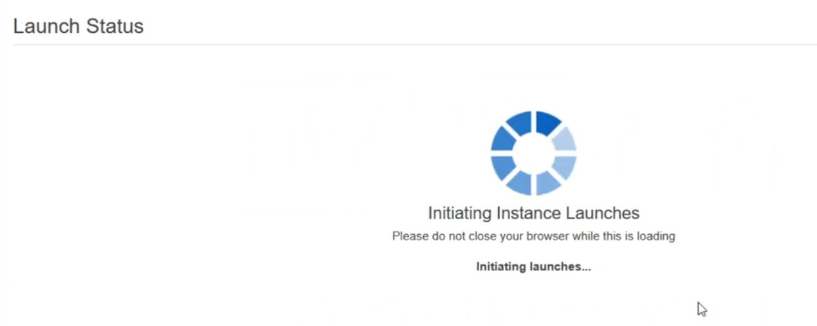

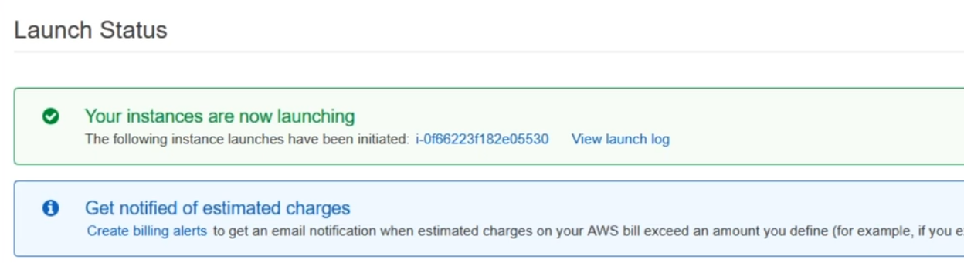

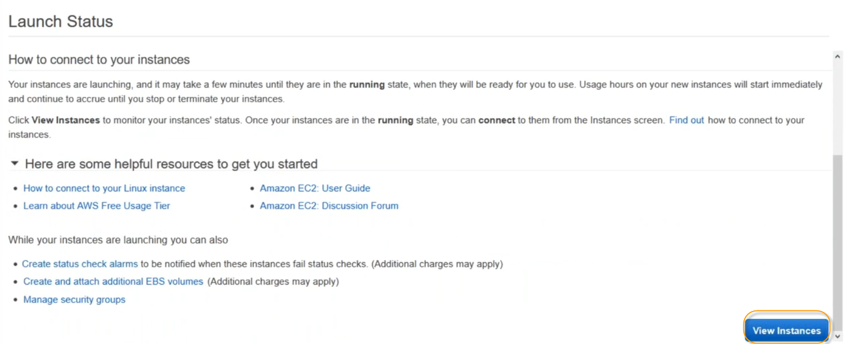

Click on “View Instances”

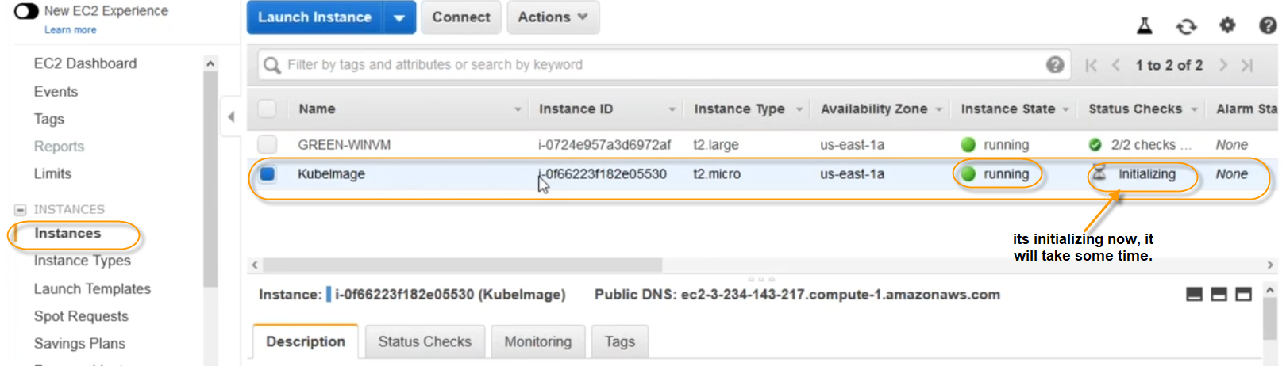

Lets connect our images, to check whether the bootstrap script executed to install docker , kubeadm, kubectl

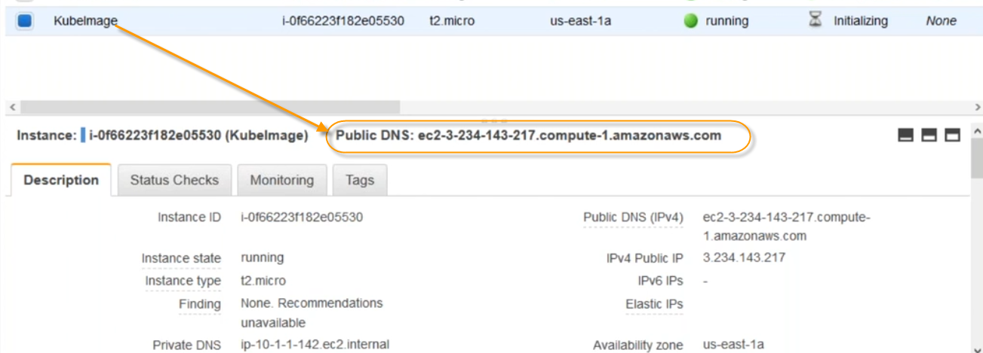

Open putty

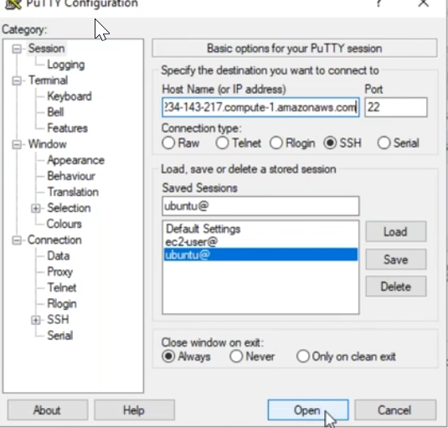 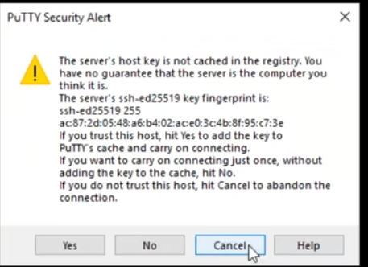

Click on Yes



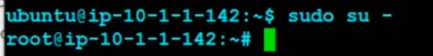

#docker version

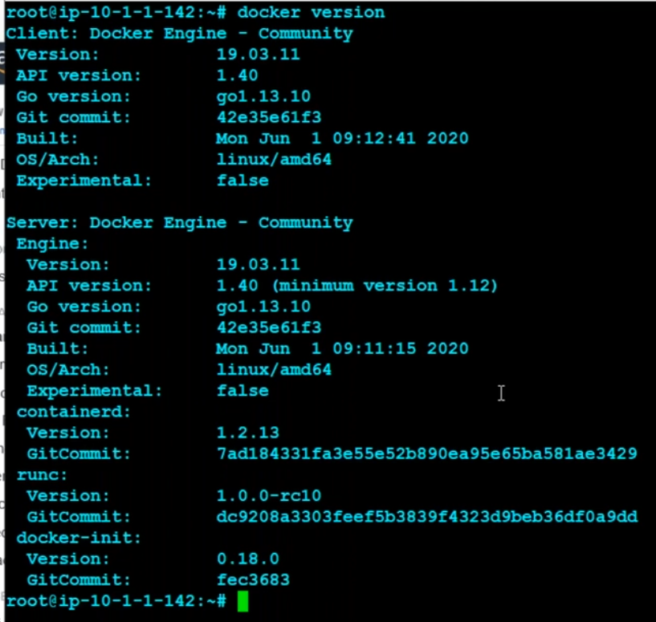

#kubectl version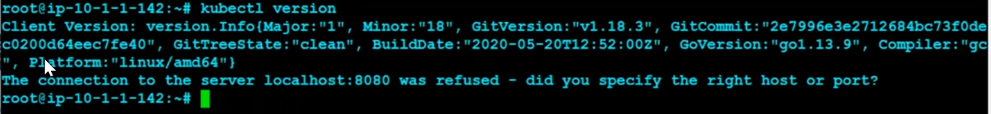

#kubeadm

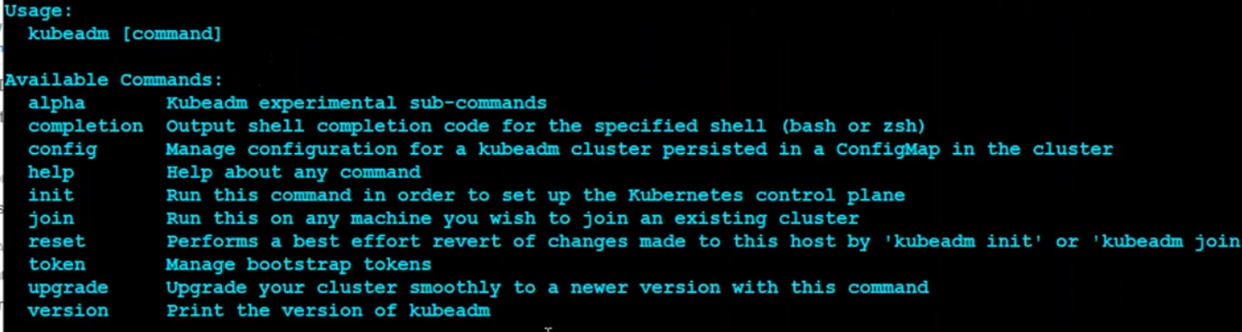

## Now I will convert above created image to a MASTER image

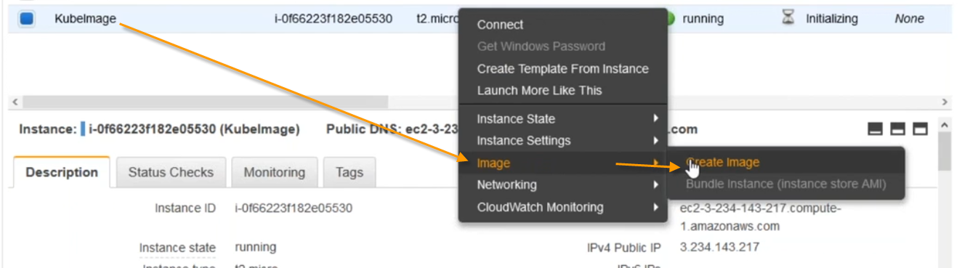

Click on Create Image

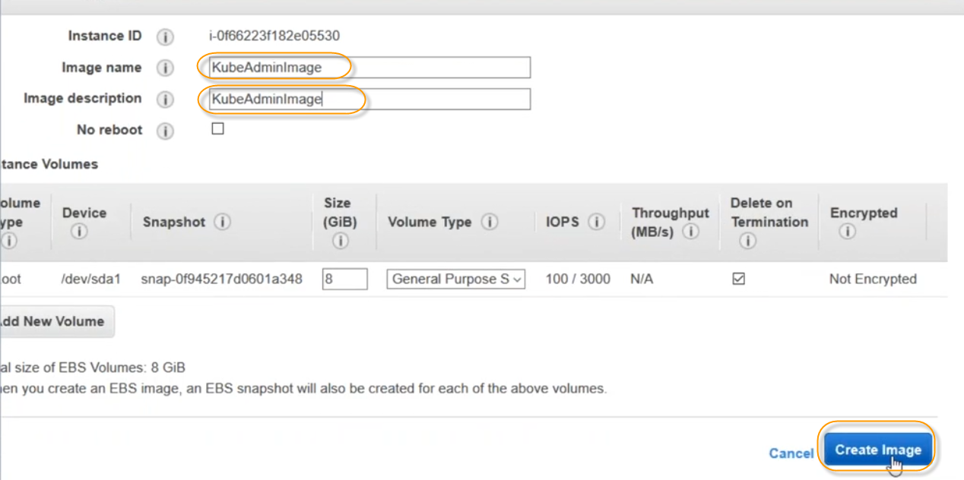

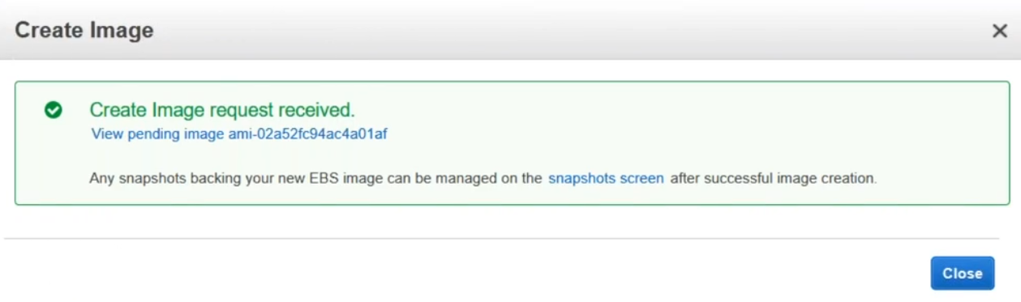

When you’re creating an image , AMI will come and your server will disconnect

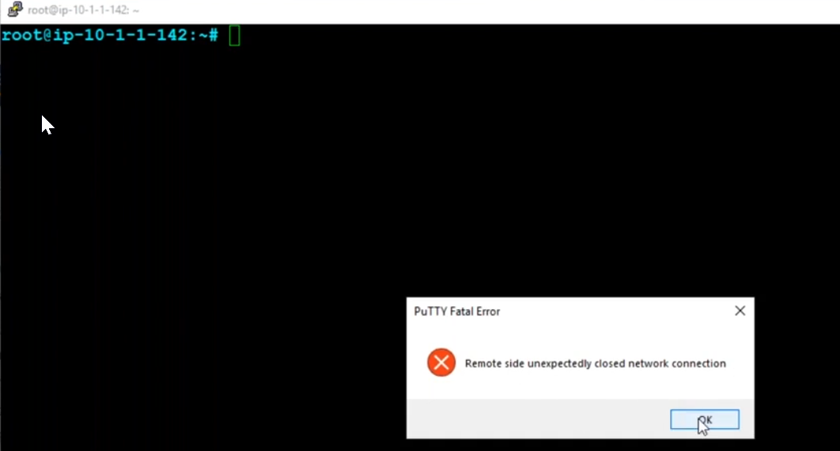

To check the AMI , whether the image is creating or not, click on AMIs and check

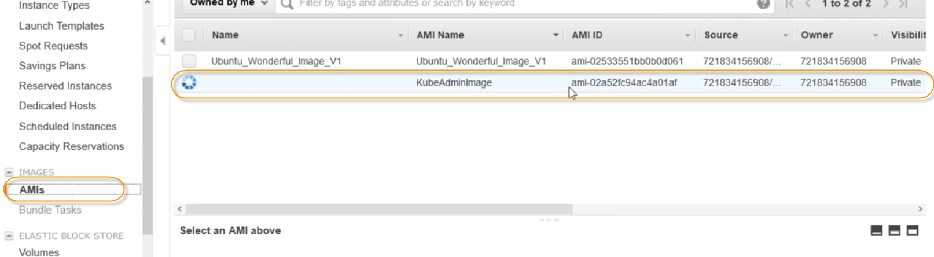



Give the name to this image

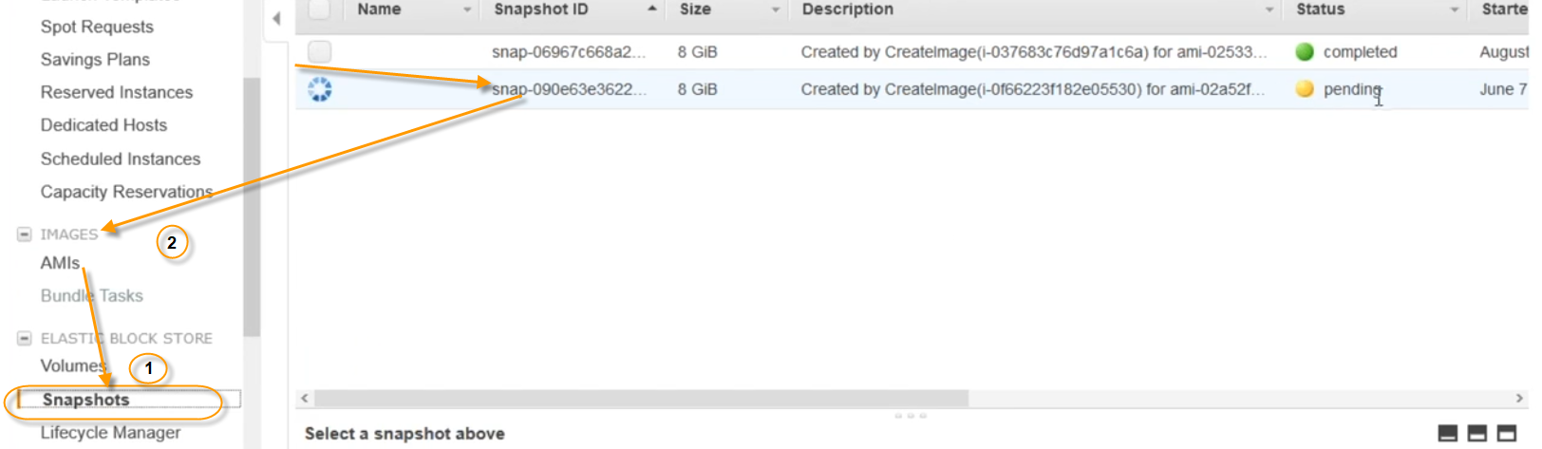

First it will create a snapshot, and from snapshot it will create an image.